Sports and Games
1.play (играть в)
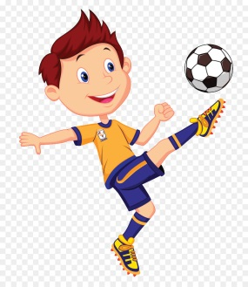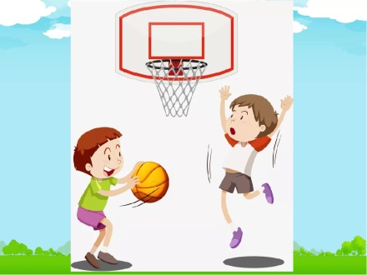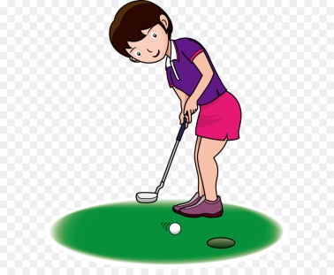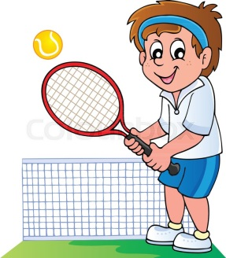
football basketball golf tennis
2.do (заниматься)
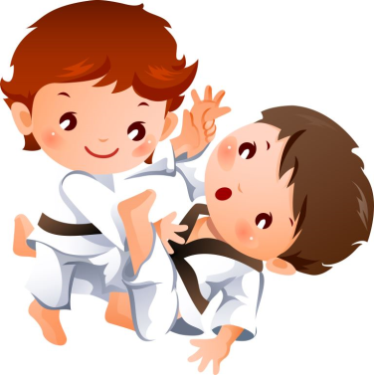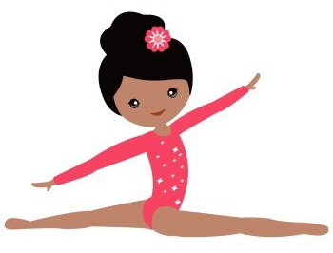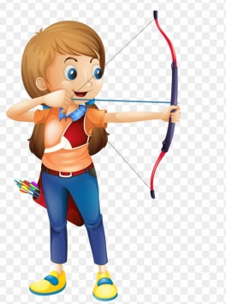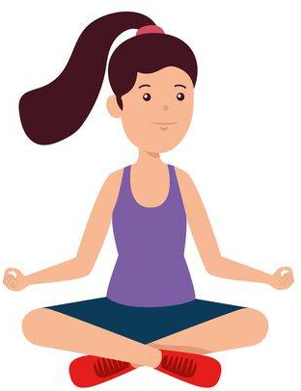
judo gymnastics archery yoga
3.go + ing
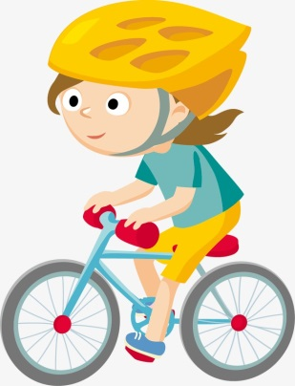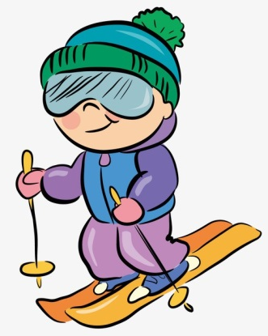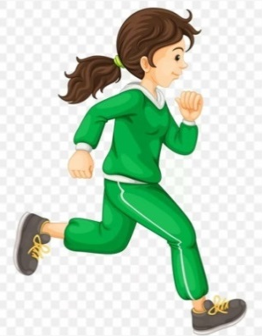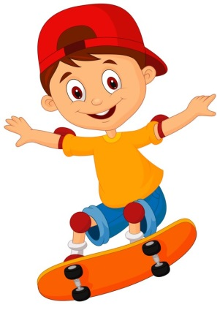
cycling skiing jogging skateboarding
4.V
cycle ski jog skateboard
1.Do you do judo? - Yes, I do. I do judo.
2.Do you play golf? - No, I don’t. I don’t play golf.
3.Do you go cycling? - Yes, I go cycling. 4.Do you cycle? -Yeah./ Nope.

