Дорогой друг!

Перед тобой культурный дневник школьника. Он предназначен не для выставления отметок и записывания домашнего задания. Он станет тебе полезен в другом.
В прошлом (да и сегодня) в России существовала традиция – люди вели дневники, записывая в них свои впечатления об увиденном, прочитанном, прочувствованном. Многие из этих дневников стали впоследствии основой для создания знаменитых книг, проведения научных исследований, написания энциклопедий и словарей.
Твой культурный дневник поможет тебе сделать свои наблюдения,
открытия, проекты и исследования в области истории, культуры и искусства Краснодарского края, твоей станицы. В нем ты сможешь представить собственные мысли после посещения музеев, концертных залов, памятных исторических мест своей малой родины. Чтобы украсить дневник, ты можешь (вместе с родителями) подготовить фотографии, рисунки, коллажи, добавить в него тексты и другие материалы.
Желаем тебе интересных встреч, путешествий, знакомств с музыкой, спектаклями, выставками, народными традициями, архитектурными сооружениями!
Удачи!

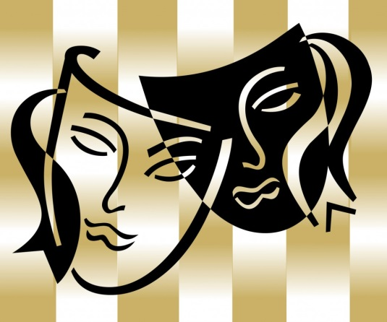
ТЕАТР
___________________________________________________________________________________________________________________________________________________________________________________________________________________________________________________________________________________________________________________________________________________________________________________________________________________________________________________________________________________________________________________________________________________________________________________________________________________________________________________________________________________________________________________________________________________________________________________________________________________________________________________________________________________________________________________________________________________________________________________________________________________________________________________________________________________________________________________________________________________________________________________________________________________________________________________________________________________________________________________________________________________________________________________________________________________________________________________________________________________________________________________________________________________________________________________________________________________________________________________________________________________________________________________________________________________________________________________________________________________________________________________________________________________________________________________________________________________________________________________________________________________________________________________________________________________________________________________________________________________________________________________________________________________________________________________________________________________________________________________________________________________________________________________________________________________________________________________________________________________________________________________________________________________________________________________________________________________________________________________________________________________________________________________________________________________________________________________________________________________________________________________________________________________________________________________________________________________________________________________________________________________________________________________________________________________________________________________________
КИНЕМАТОГРАФ
________________________________________________________________________________________________________________________________________________________________________________________________________________________________________________________________________________________________________________________________________________________________________________________________________________________________________________________________________________________________________________________________________________________________________________________________________________________________________________________________________________________________________________________________________________________________________________________________________________________________________________________________________________________________________________________________________________________________________________________________________________________________________________________________________________________________________________________________________________________________________________________________________________________________________________________________________________________________________________________________________________________________________________________________________________________________________________________________________________________________________________________________________________________________________________________________________________________________________________________________________________________________________________________________________________________________________________________________________________________________________________________________________________________________________________________________________________________________________________________________________________________________________________________________________________________________________________________________________________________________________________________________________________________________________________________________________________________________________________________________________________________________________________________________________________________________________________________________________________________________________________________________________________________________________________________________________________________________________________________________________________________________________________________________________________________________________________________________________________________________________________________________________________________________________________________________________________________________________________________________________________________________________________________________________________________________________________________________________________________________________________________________________ЛИТЕРАТУРА
___________________________________________________________________________________________________________________________________________________________________________________________________________________________________________________________________________________________________________________________________________________________________________________________________________________________________________________________________________________________________________________________________________________________________________________________________________________________________________________________________________________________________________________________________________________________________________________________________________________________________________________________________________________________________________________________________________________________________________________________________________________________________________________________________________________________________________________________________________________________________________________________________________________________________________________________________________________________________________________________________________________________________________________________________________________________________________________________________________________________________________________________________________________________________________________________________________________________________________________________________________________________________________________________________________________________________________________________________________________________________________________________________________________________________________________________________________________________________________________________________________________________________________________________________________________________________________________________________________________________________________________________________________________________________________________________________________________________________________________________________________________________________________________________________________________________________________________________________________________________________________________________________________________________________________________________________________________________________________________________________________________________________________________________________________________________________________________________________________________________________________________________________________________________________________________________________________________________________________________________________________________________________________________________________________________________________________________________
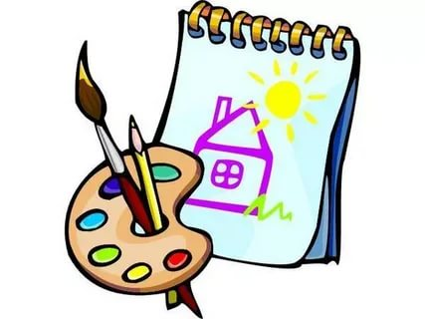
ИЗОБРАЗИТЕЛЬНОЕ ИСКУССТВО
___________________________________________________________________________________________________________________________________________________________________________________________________________________________________________________________________________________________________________________________________________________________________________________________________________________________________________________________________________________________________________________________________________________________________________________________________________________________________________________________________________________________________________________________________________________________________________________________________________________________________________________________________________________________________________________________________________________________________________________________________________________________________________________________________________________________________________________________________________________________________________________________________________________________________________________________________________________________________________________________________________________________________________________________________________________________________________________________________________________________________________________________________________________________________________________________________________________________________________________________________________________________________________________________________________________________________________________________________________________________________________________________________________________________________________________________________________________________________________________________________________________________________________________________________________________________________________________________________________________________________________________________________________________________________________________________________________________________________________________________________________________________________________________________________________________________________________________________________________________________________________________________________________________________________________________________________________________________________________________________________________________________________________________________________________________________________________________________________________________________________________________________________________________________________________________________________________________________________________________________________________________________________________________________________________________________________________________________
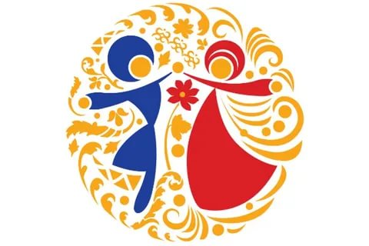
НАРОДНАЯ КУЛЬТУРА
___________________________________________________________________________________________________________________________________________________________________________________________________________________________________________________________________________________________________________________________________________________________________________________________________________________________________________________________________________________________________________________________________________________________________________________________________________________________________________________________________________________________________________________________________________________________________________________________________________________________________________________________________________________________________________________________________________________________________________________________________________________________________________________________________________________________________________________________________________________________________________________________________________________________________________________________________________________________________________________________________________________________________________________________________________________________________________________________________________________________________________________________________________________________________________________________________________________________________________________________________________________________________________________________________________________________________________________________________________________________________________________________________________________________________________________________________________________________________________________________________________________________________________________________________________________________________________________________________________________________________________________________________________________________________________________________________________________________________________________________________________________________________________________________________________________________________________________________________________________________________________________________________________________________________________________________________________________________________________________________________________________________________________________________________________________________________________________________________________________________________________________________________________________________________________________________________________________________________________________________________________________________________________________________________________________________________________________________
МУЗЫКА

_______________________________________________________________________________________________________________________________________________________________________________________________________________________________________________________________________________________________________________________________________________________________________________________________________________________________________________________________________________________________________________________________________________________________________________________________________________________________________________________________________________________________________________________________________________________________________________________________________________________________________________________________________________________________________________________________________________________________________________________________________________________________________________________________________________________________________________________________________________________________________________________________________________________________________________________________________________________________________________________________________________________________________________________________________________________________________________________________________________________________________________________________________________________________________________________________________________________________________________________________________________________________________________________________________________________________________________________________________________________________________________________________________________________________________________________________________________________________________________________________________________________________________________________________________________________________________________________________________________________________________________________________________________________________________________________________________________________________________________________________________________________________________________________________________________________________________________________________________________________________________________________________________________________________________________________________________________________________________________________________________________________________________________________________________________________________________________________________________
АРХИТЕКТУРА
________________________________________________________________________________________________________________________________________________________________________________________________________________________________________________________________________________________________________________________________________________________________________________________________________________________________________________________________________________________________________________________________________________________________________________________________________________________________________________________________________________________________________________________________________________________________________________________________________________________________________________________________________________________________________________________________________________________________________________________________________________________________________________________________________________________________________________________________________________________________________________________________________________________________________________________________________________________________________________________________________________________________________________________________________________________________________________________________________________________________________________________________________________________________________________________________________________________________________________________________________________________________________________________________________________________________________________________________________________________________________________________________________________________________________________________________________________________________________________________________________________________________________________________________________________________________________________________________________________________________________________________________________________________________________________________________________________________________________________________________________________________________________________________________________________________________________________________________________________________________________________________________________________________________________________________________________________________________________________________________________________________________________________________________________________________________________________________________________________________________________________________________________________________________________________________________________________________________________________________________________________________________________________________________________________________________________________________________________________________________________________________________________

