Department of Education Administration
municipal formation Shcherbinovsky district

Municipal budgetary institution of additional education

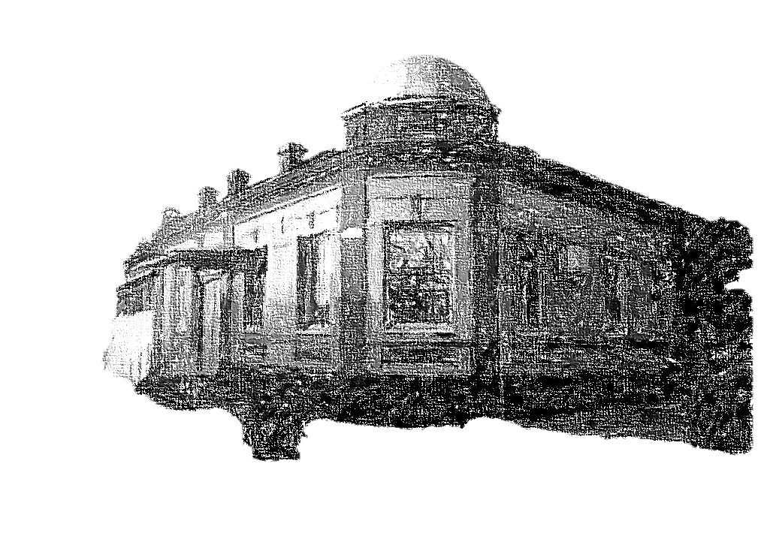
House of children's creativity of the municipality
Shcherbinovsky district, Staroshcherbinovskaya village

"ARCHITECTURAL MONUMENTS
STANITS OF STAROSCHERBINOVSKAYA
LATE XIX - BEGINNING XX CENTURIES."
illustrated guidebook

Contributing authors:
Smola Elena Valerievna,
additional education teacher,
students of the “ENGLISH FOR CHILDREN” association

st. Staroshcherbinovskaya,
2025


FROM THE COMPILERS
Architecture is an important part of the material and cultural environment that surrounds each of us. Of particular importance are historical monuments that embody many aspects of human activity. Therefore, the problem of preserving them in their original state is also relevant, so that new generations can join in the results of the creative work of their ancestors.
The village of Staroshcherbinovskaya, founded in 1794, is located in the north of the Krasnodar Territory, in the lower reaches of the Eya River. Within the boundaries of the village there are about two dozen ancient buildings dating back to the late electrical period with elements of the “Russian style”. They are not only an adornment of the municipality, but also guardians of the history of our Small Motherland.
Over time, buildings deteriorate, change and rebuild, and sometimes even collapse. In addition, among the “long-livers” that still stand today on the streets of the village, there are many so-called “nameless” objects, information about which is lost in the “depths” of history.
The era of communism had a huge influence on this state of affairs, when the memory of Russia’s past was literally erased from the consciousness of many generations, churches were destroyed, values ​​were replaced, and facts were distorted.
Now we look at the past in a completely different way, and it is very good that, thanks to the memory of the people, some names, surnames and biographies of fellow villagers - outstanding people of that time - have reached us.

The purpose of our guide is to preserve the history of our people, expressed in the architectural monuments of the past.
Primary school

Date of construction: 1914
Location: Engels street, 160 (at the intersection of Krasin and Engels streets). Photo 1-3
On the façade of the building there are the letters “A. D.N.” and year of construction.
Historical information: Since 1938 - an elementary school with a duration of study of 4 years.
Since 1951 - a school with 7 years of education.
Since 1965, a secondary school with 10 years of education.
Currently, there is a local branch of the all-Russian public-state organization DOSAAF here.
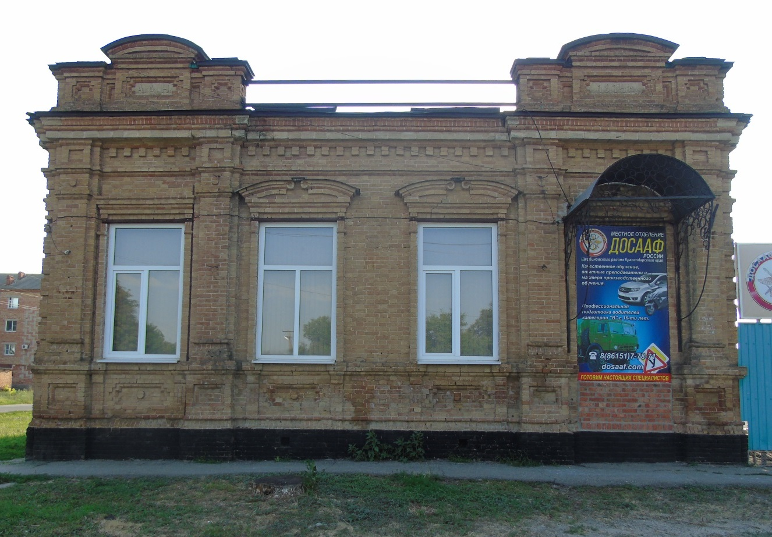

Photo 1 (author E.V. Smola)

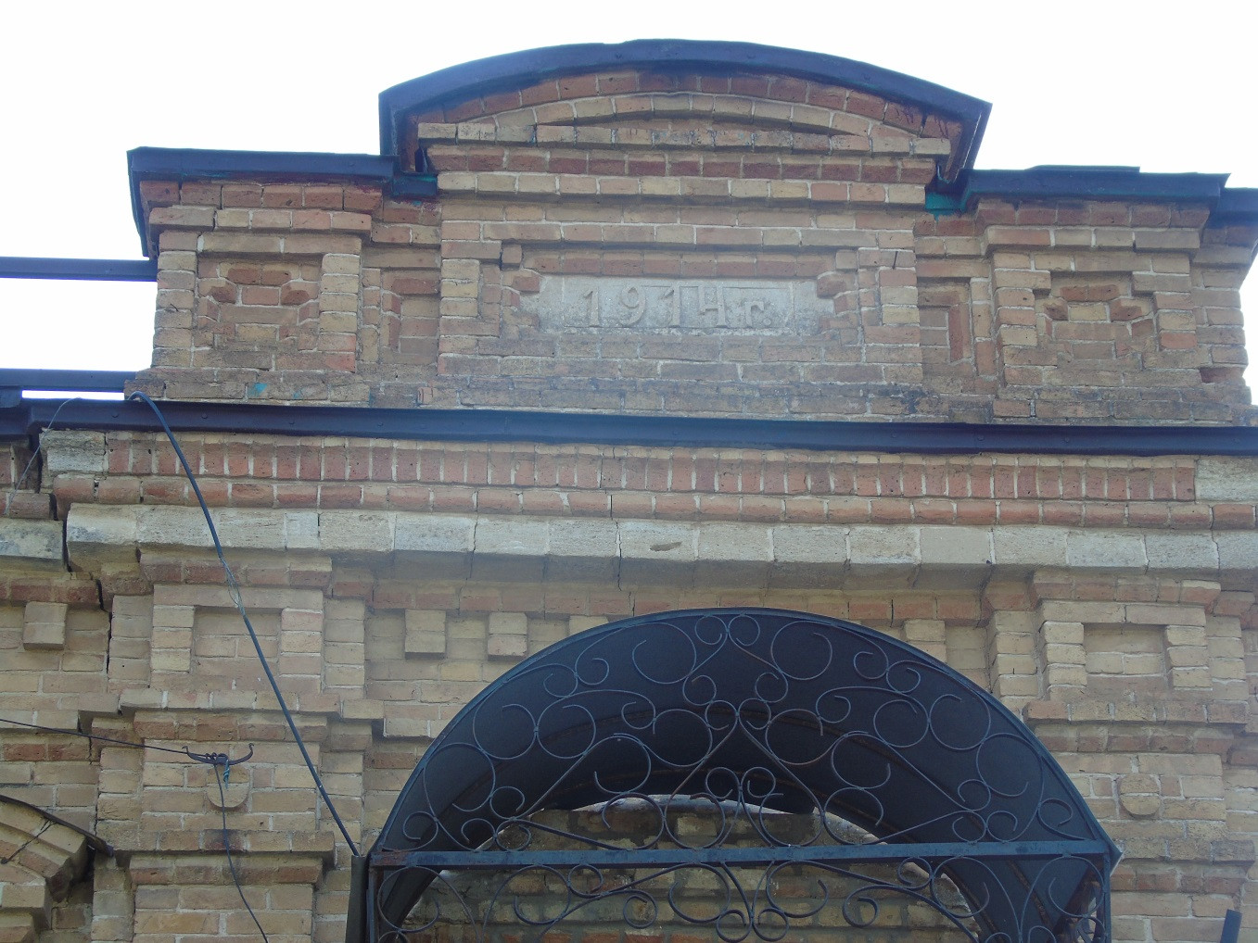
Photo 2 (author E.V. Smola)
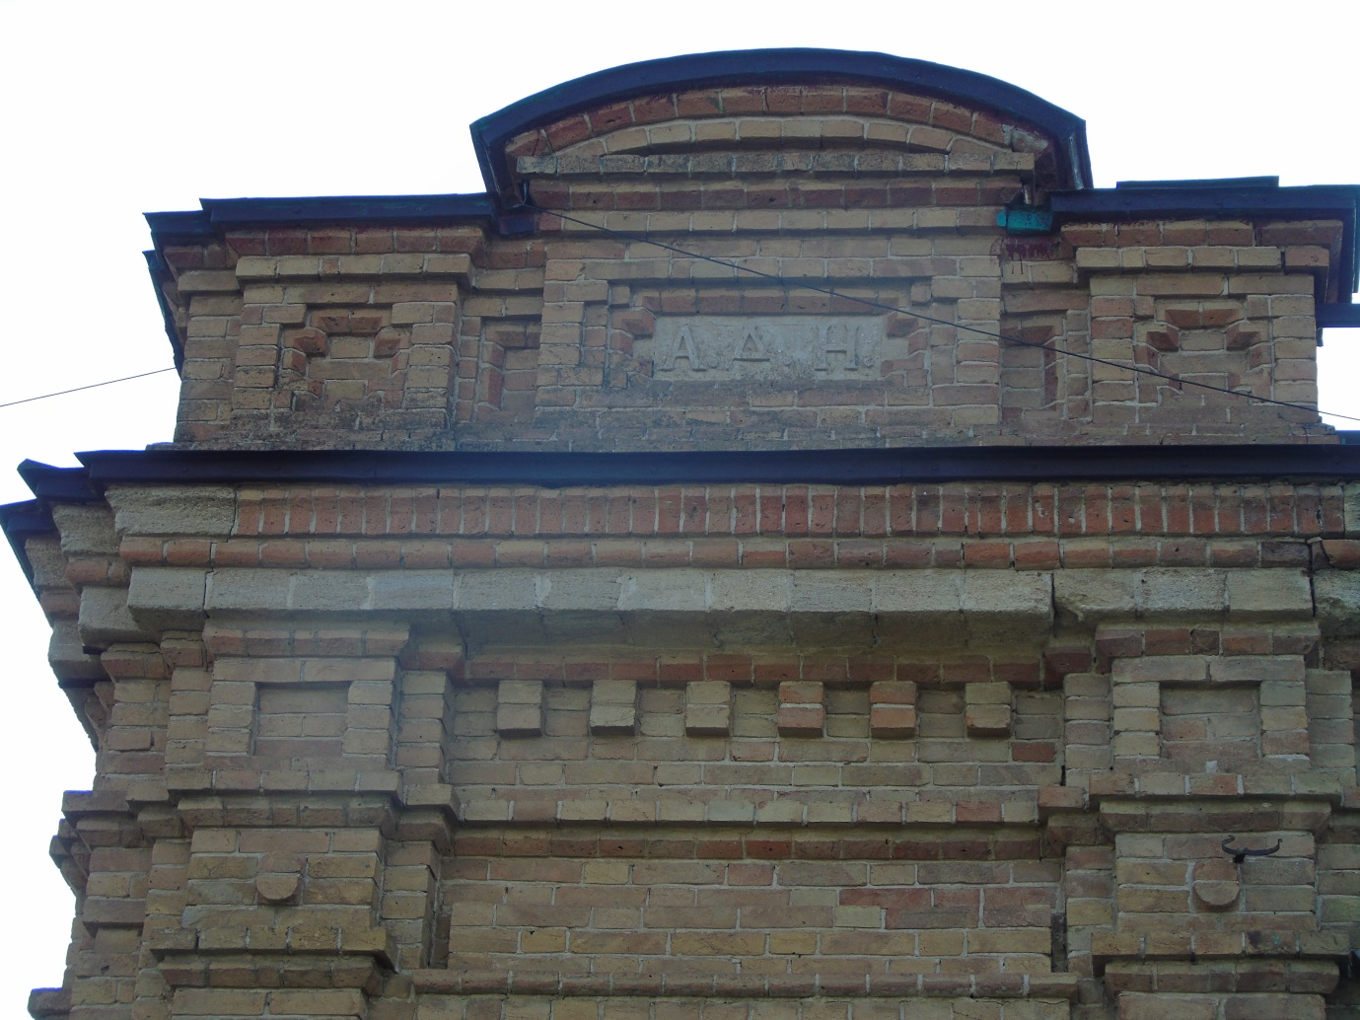
Photo 3 (author E.V. Smola)
Parish School for Non-Local Residents
(Nazarov One-Class School)
Date of construction: 1903.
Location: 195 Shevchenko Street. Photos 4, 5
Historical background: The school was named Nazarovsky in honor of one of the sons of the Cossack Shcherbinovsky Kuren of the Black Sea Cossack army, Karp Nazarovich Nazarov.
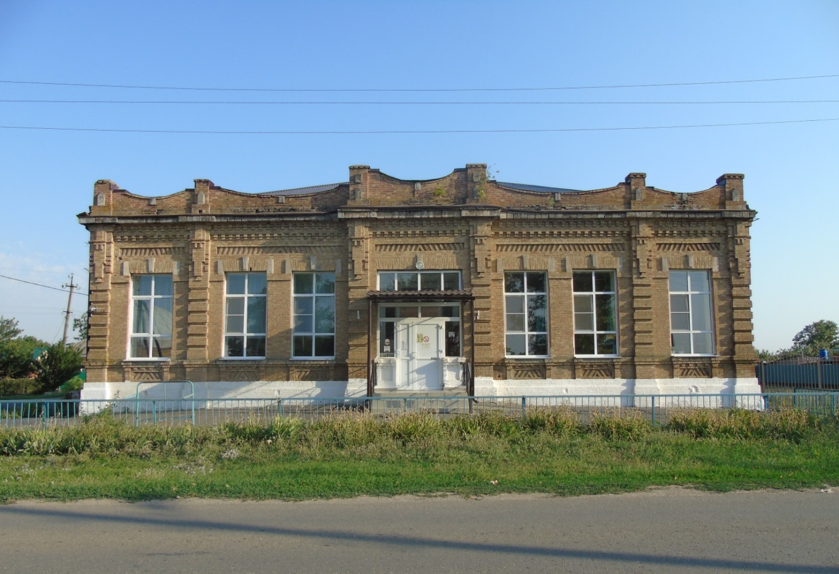
Photo 4 (author E.V. Smola)
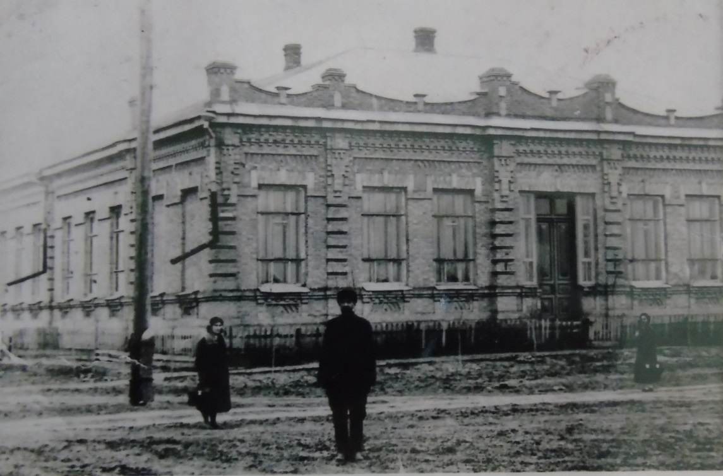
Photo 5, 1939
(Archive Department of the administration of the Shcherbinovsky district municipality)

Nazarov (Nazirov) – An Old Shcherbinovsky Cossack Officer Family of Armenian Origin
The Nazarov family traces its origins to an Armenian bourgeois from Rostov-Nakhichevan, who petitioned to be enlisted as a Cossack of the Shcherbinovsky kuren of the Black Sea Cossack Army. His request read as follows:
"I wish to settle in this army and continue my military service in it under His Imperial Majesty. I humbly request the Black Sea Military Chancellery to accept me into the estate of the Black Sea Cossacks, enroll me in the Shcherbinovsky kuren, and assign me to serve in the Cavalry Regiment of His Excellency, Army Colonel Golub... Attached to this petition, from the city of Nakhichevan, is the signature of Karpo Nazarov, son of Nazarov, an Armenian bourgeois."
The petition was granted, and in due course, Nazarov rose to the rank of Major General and became the commander of the Horse-Artillery Brigade of the Kuban Cossack Army. His sons, Cornet Yuri Karpovich Nazarov (b. 1821) and Esaul Ivan Karpovich Nazarov (b. 1831), became known for their philanthropy and contributions to education.

Nazarov School in Historical Records
The Kuban Regional Gazette dated January 23, 1904, recounts an episode from the cultural life of teachers in Staroshcherbinovskaya stanitsa, mentioning the Nazarov School:
*"During the 1903/04 academic year, the teachers of our stanitsa formed a 'Circle of Theater Enthusiasts.' Each member contributed to setting up a stage. Such an initiative is truly commendable, as our stanitsa, with a population of 14,000, lacks any entertainment.
On December 7, a performance was held featuring Gogol’s "Marriage" and Chekhov’s vaudeville "The Bear." Almost all tickets were sold out days in advance, and on the day of the performance, many were turned away. Only a few managed to secure additional seating by special request. The acting was excellent, with each performer knowing their role perfectly. The audience was delighted and eagerly awaited the next performance.
Alas, the arrival of the new leap year did not fulfill its promise.
On Tuesday, January 13, 1904, the 'Circle of Theater Enthusiasts' gathered to select new material for the next play. However, the head of the group did not attend the meeting, nor did the principal of the Nazarov Primary School. The second teacher (the wife of the principal of the two-class school) refused to participate entirely, and as a result, the meeting was canceled. It now seems unlikely that another performance will take place, which is truly regrettable."*

Present-Day Status
Today, the historic building houses elementary school classrooms of Municipal Secondary School No. 3 (MBOU SOSh No. 3).
Men's Parish School
Date of construction: 1895. Photos 6-9
Location: 86 Lenin Street (intersection of Lenin and Pervomaiskaya streets).

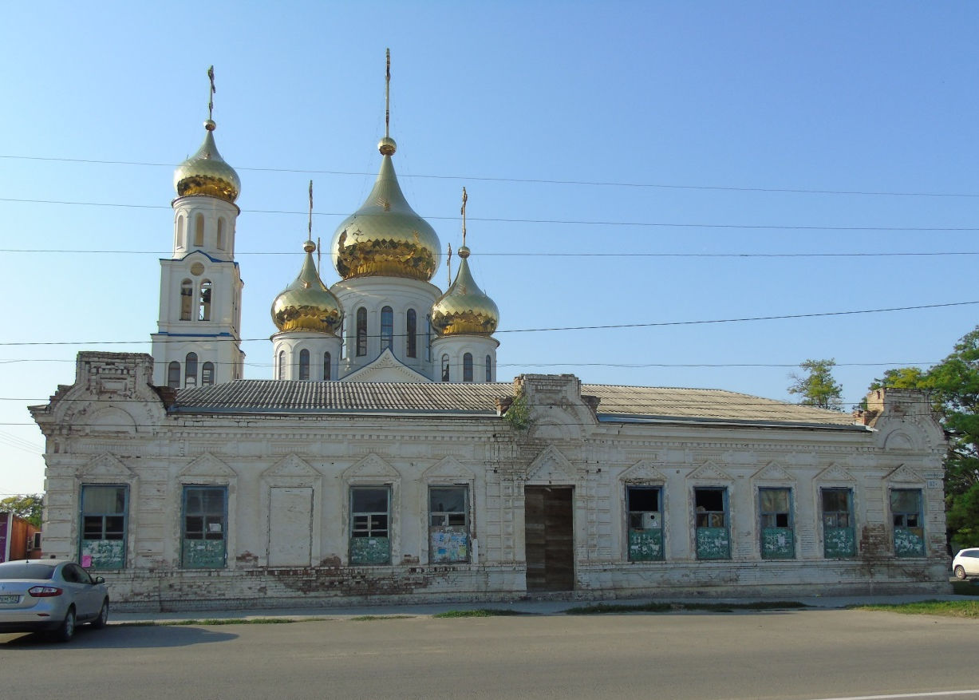
Photo 6 (author E.V. Smola)
Historical background: An online source referring to the State Archive of the Stavropol Territory (hereinafter GASK) reports:
"F.135. Op.52. D.230 On the construction of a parish school in the village of Staroshcherbinovskaya. 1894
F.135. Op.49. d.415 On the extension of the premises to the parish school of art. Staroshcherbinovskaya for the premises, from the old school building to the new school building. 1891
F.135. Op.63. d.403 On the permission of church money for the construction of a building for a women's church school in the village of Staroshcherbinovskaya. 1905 – 1907". [10]

Thus, it becomes obvious that this building belonged specifically to the men's parochial school, since the women's parochial school was built much later.
After the revolution, the building housed an orphanage, then a 24-hour kindergarten.
In the 40s and 60s, there was a Cultural center here, where secondary school students attended various clubs and sections, including ballroom dancing lessons.
Since 1965, there has been a sports hall of the Children's and Youth Sports School in the building.
From 2007 to the present, these are the auxiliary rooms of the Church of the Intercession of the Most Holy Theotokos.

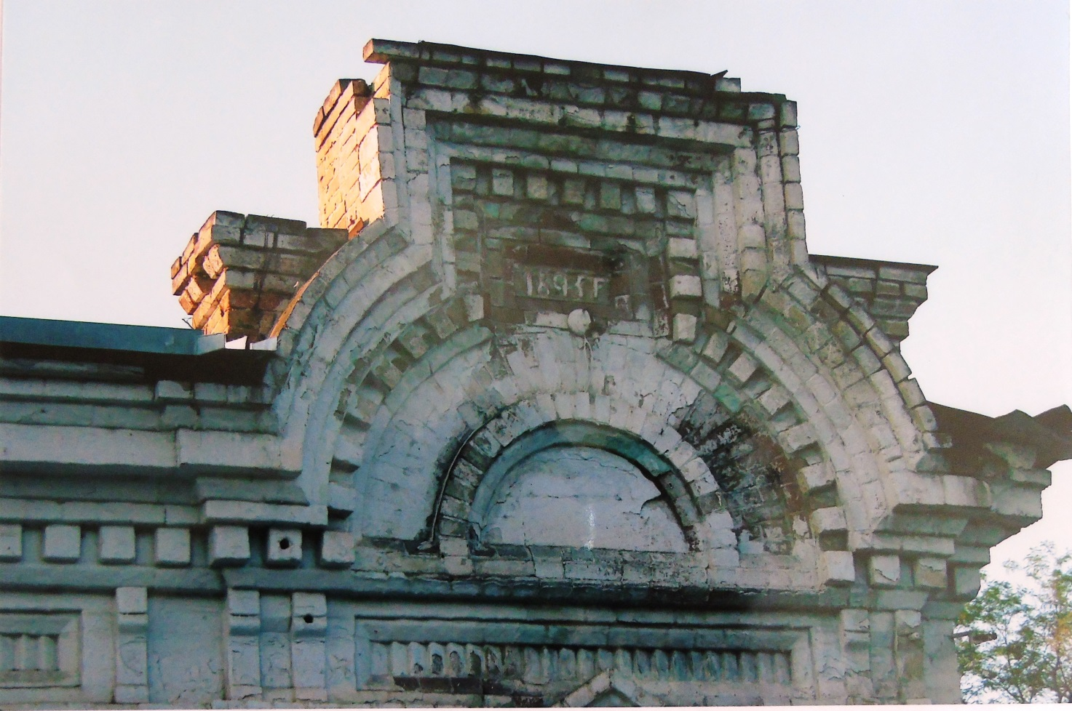

Photo 7. The end of the XX-beginning of the XXI century
(Archive Department of the administration of the Shcherbinovsky district municipality)

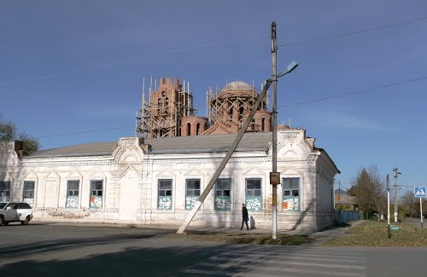
Photo 8. The beginning of the XXI century.
(Archive Department of the administration of the Shcherbinovsky district municipality)
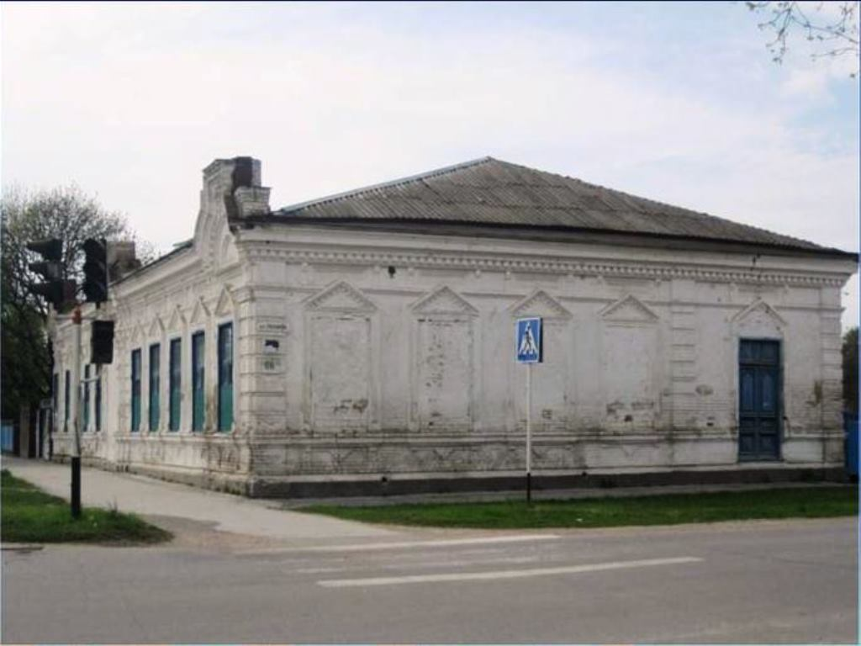
Photo 9. The beginning of the XXI century.
(Archive Department of the administration of the Shcherbinovsky district municipality)
Savings and loan association

Date of construction: 1906. Photos 10, 11
Location: the intersection of Krasnaya (No. 69) and Pervomaiskaya (No. 62) streets
Historical background: The archive department has preserved information about another of its names (probably after the revolution) – "people's house".
It was used for the needs of a savings and loan partnership ("... a type of cooperative small-scale credit institution that existed in Russia in the second half of the 19th century and the first half of the 20th century. The purpose of savings and loan partnerships was short-term lending to peasants, artisans and small traders. The basis of the activity ... was the share capital, which was to be contributed by the members of the savings and loan partnership"). [11]
In addition to providing loans to those in need at low interest rates (which was very convenient for the poor), the partnership also organized cultural leisure for residents of the village – the building had a spacious hall with a stage, decorations and places for the public, where real theatrical plays were staged, dance evenings were held, and a brass band played.
The Partnership also provided all possible financial assistance to local educational institutions.
Thanks to this institution, a midwife was invited to the village, and the partnership took over all the expenses for her maintenance. Thus, free medical care was provided to local women in labor. The partnership also allocated 1.5 thousand rubles for the maintenance of a doctor.
A public library with a free reading room was opened in the assignment room. [6]
In the 1960s, the district hospital was located here.
Currently, the building houses the gynecological, dental and pediatric departments of the polyclinic. In the corridors of the gynecological and dental departments, stoves with stucco (sculptural or relief decoration of the facade or interior) and painted tiles (tiles made of baked clay for lining walls and furnaces, glazed on the front side) are still preserved.
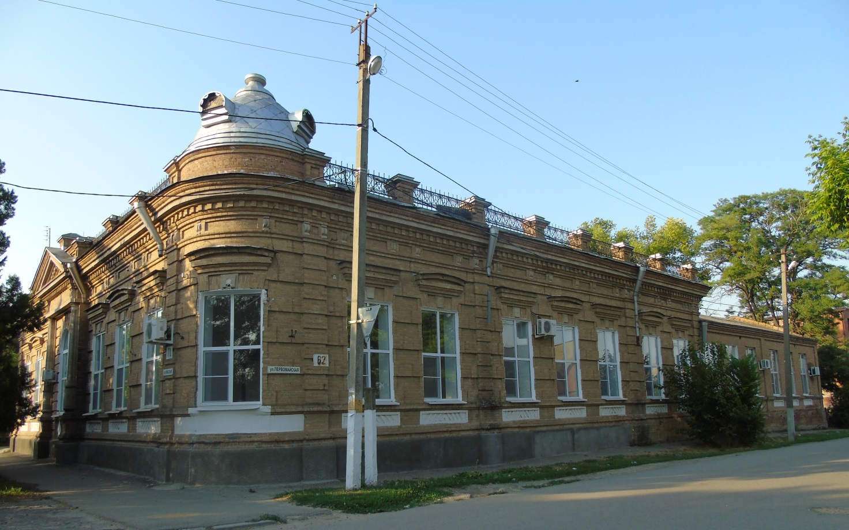
Photo 10 (author E.V. Smola)

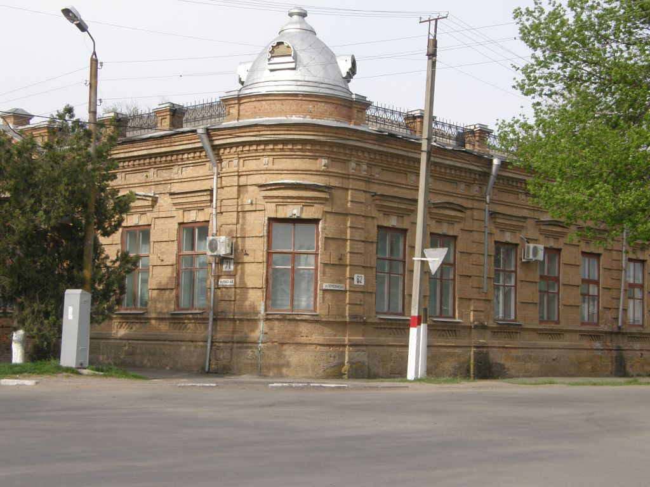
Photo 11. The beginning of the XXI century.
(Archive Department of the administration of the Shcherbinovsky district municipality)
Mikhailovskoye Higher Primary School
Date of construction: 1907-1908. Photos 12-20
Location: near the intersection of Lermontov and Krasnaya streets from Krasnaya St. (legal address: 37 Lermontova St.).
Historical background: It was built according to the decision of the Cossack village circle (the general Military Council of Cossacks, the highest body of self-government).
Since 1916, it has been transformed into a mixed gymnasium.
In 1917, after the formation of the Soviet government, he graduated from a secondary school of the second degree with 9 years of education.
In 1929, the school was reorganized into a technical college of industrial agriculture. A year later, the college was transferred to the city of Georgievsk.
In 1931, the building housed a school for peasant youth.
In 1933, he graduated from a secondary school with 10 years of education. [6]
Currently, the building houses primary school classrooms of MBOU Secondary School No. 1.
In 1913, the Law of God was taught here by the priest of the Intercession Church of the village of Staroshcherbinovskaya, Stefan Ilyich Yankov, whose incorruptible relics now rest in the chapel located in the central park of the village of Staroshcherbinovskaya.
"Information about priest Stefan Yankov according to the Clerical Register of the Holy Protection Church for 1913 (the last lifetime entry):
"... By His Grace Agafador, Bishop of Stavropol and Yekaterinodar, Stefan Yankov ... was moved by the priest to the Intercession Church of the village of Staroshcherbinovskaya to his 2nd full-time position on

September 13, 1906. He was a law teacher at the 2nd grade Mikhailovsky Law School from 1906 to 1913.

He was confirmed as the law teacher of the Staroshcherbinovsky Mikhailovsky Higher Primary School by the Director of public schools on September 1, 1913." [12]
In 1916 it was transformed into a mixed gymnasium.
Since 1917, he has been a secondary school of the II degree with 9 years of study.
In 1929, he graduated from the College of Industrial Agriculture.
In 1931, he graduated from the school of peasant youth.
In 1933, he graduated from a secondary school with 10 years of education.
Currently, the building houses primary school classrooms of MBOU Secondary School No. 1.
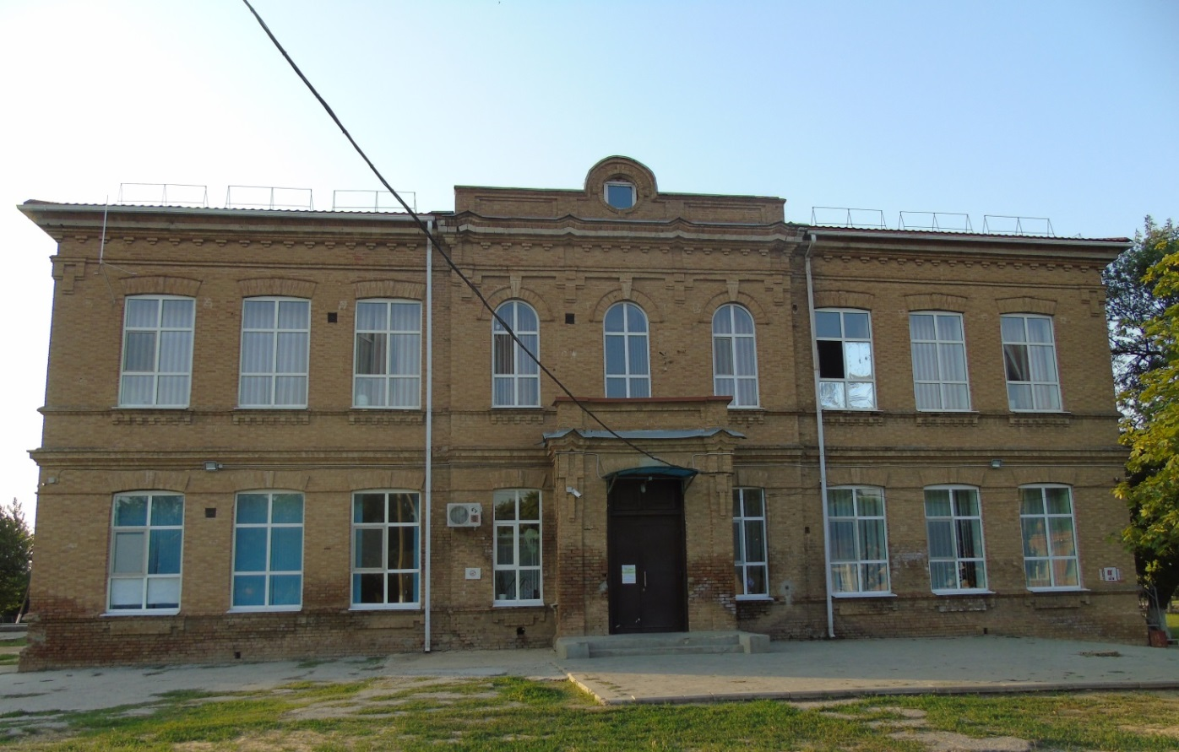
Photo 12 (author E.V. Smola)
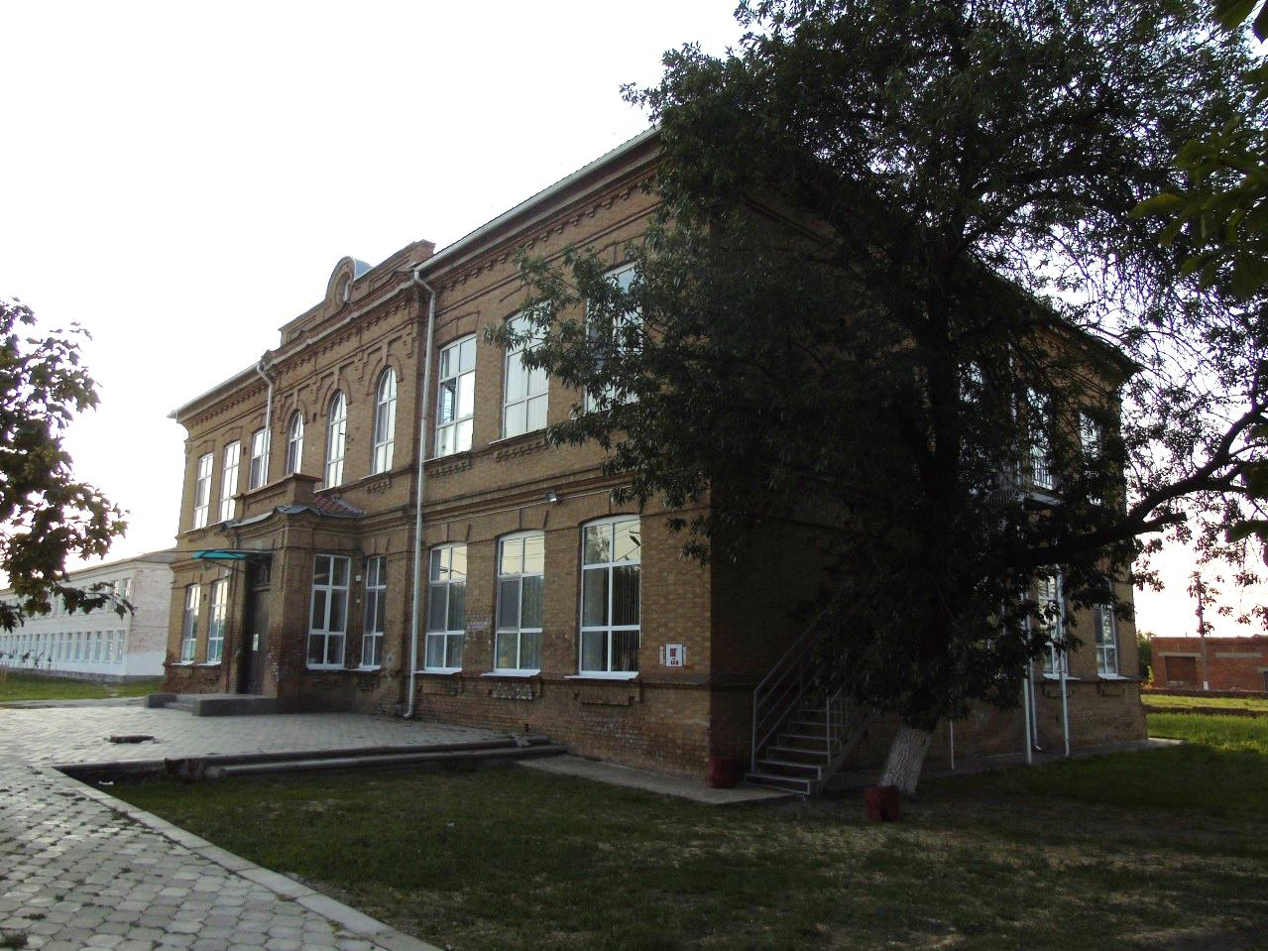
Photo 13 (author E.V. Smola)
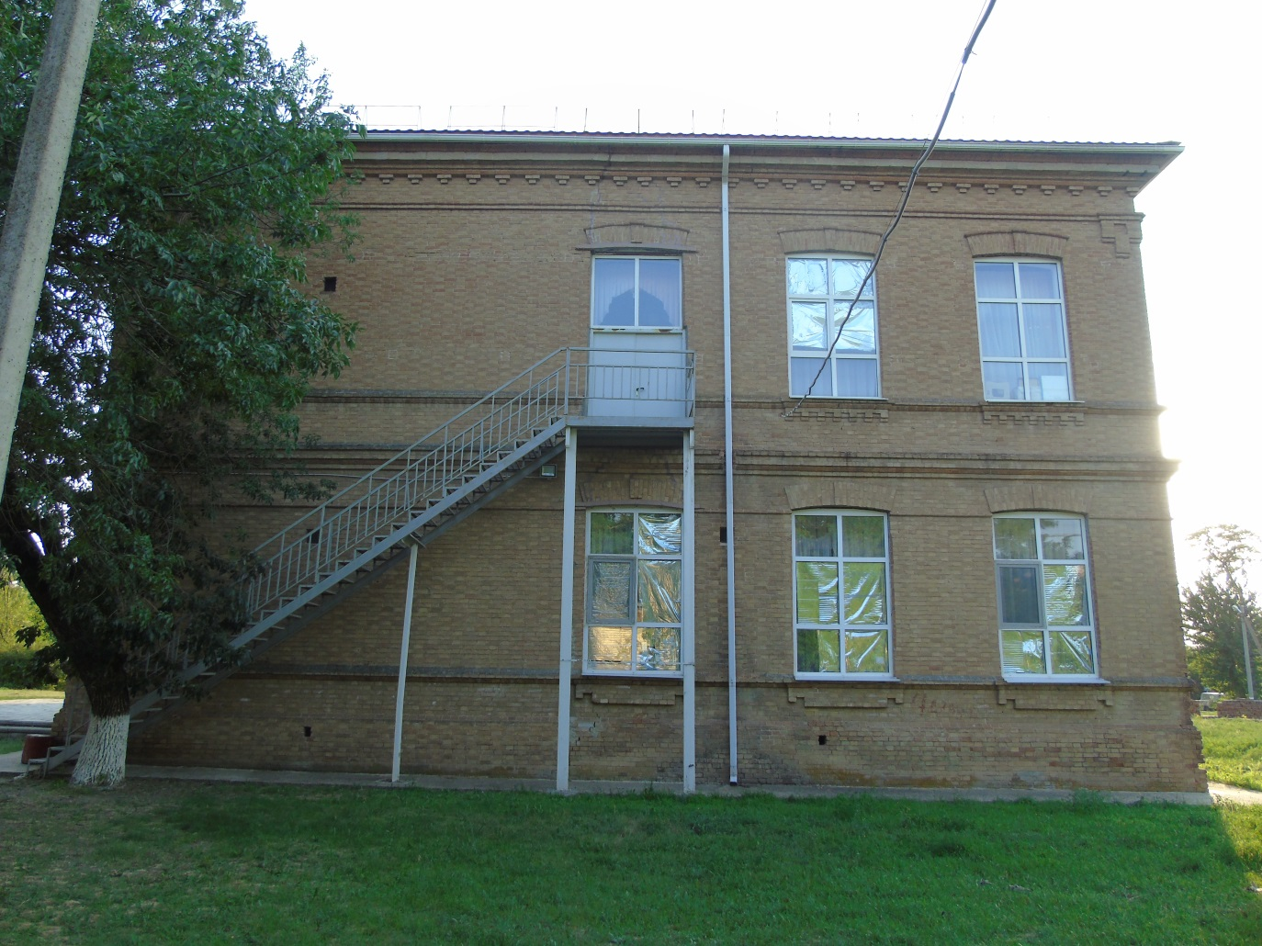
Photo 14 (author E.V. Smola)
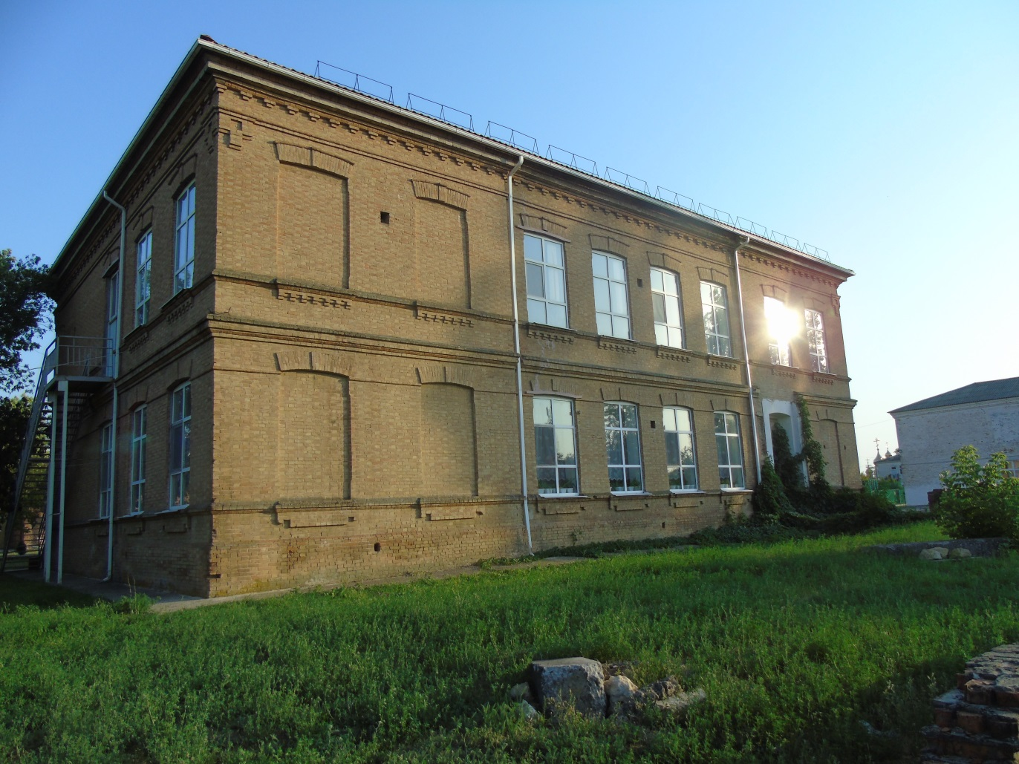
Photo 15 (author E.V. Smola)

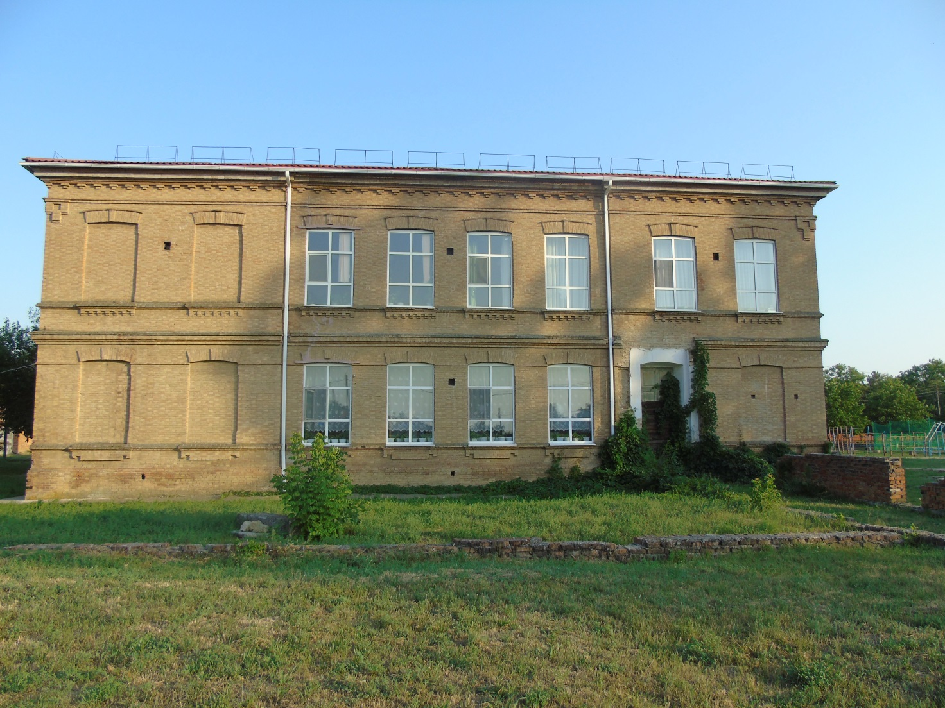
Photo 16 (author E.V. Smola)
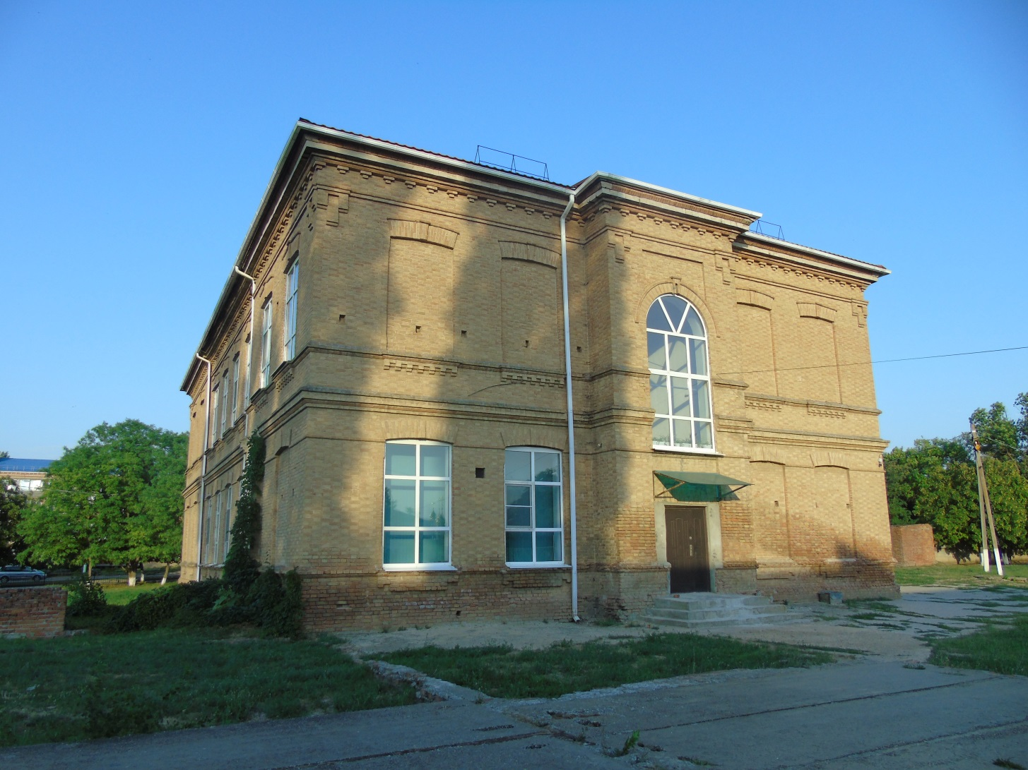
Photo 17 (author E.V. Smola)

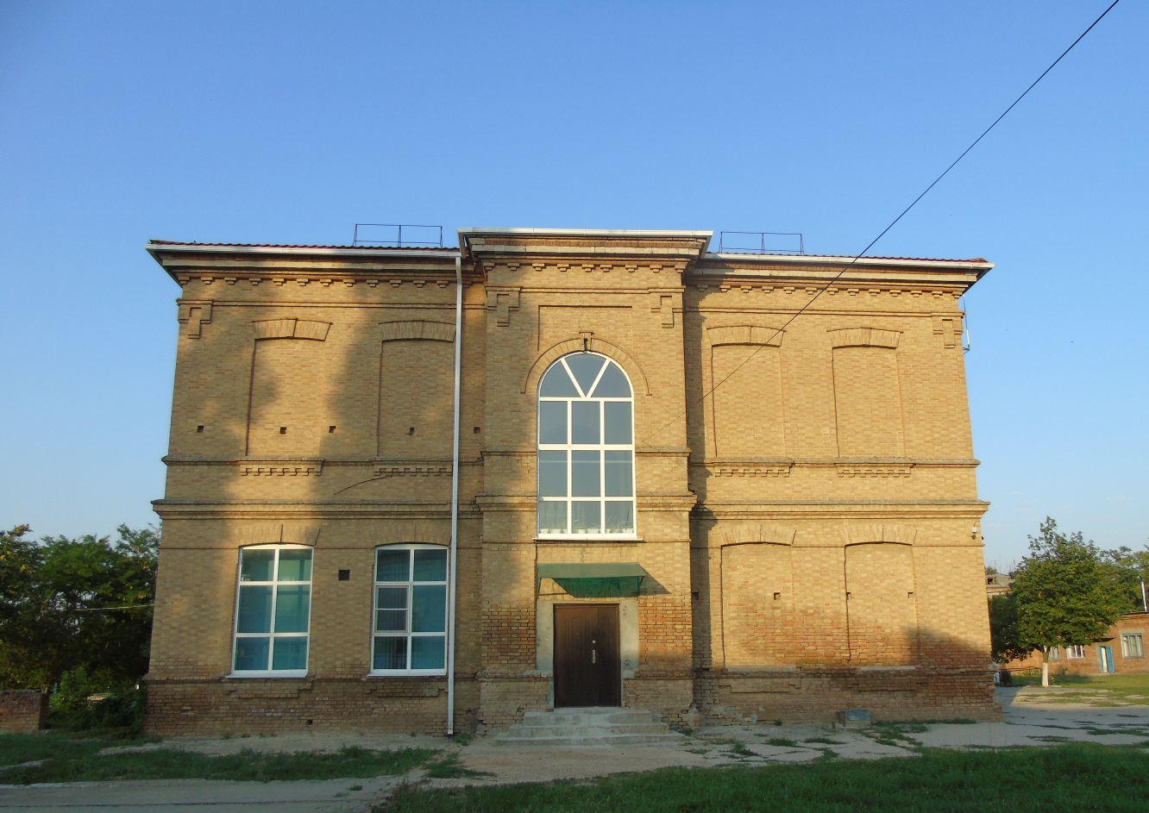
Photo 18 (author E.V. Smola)
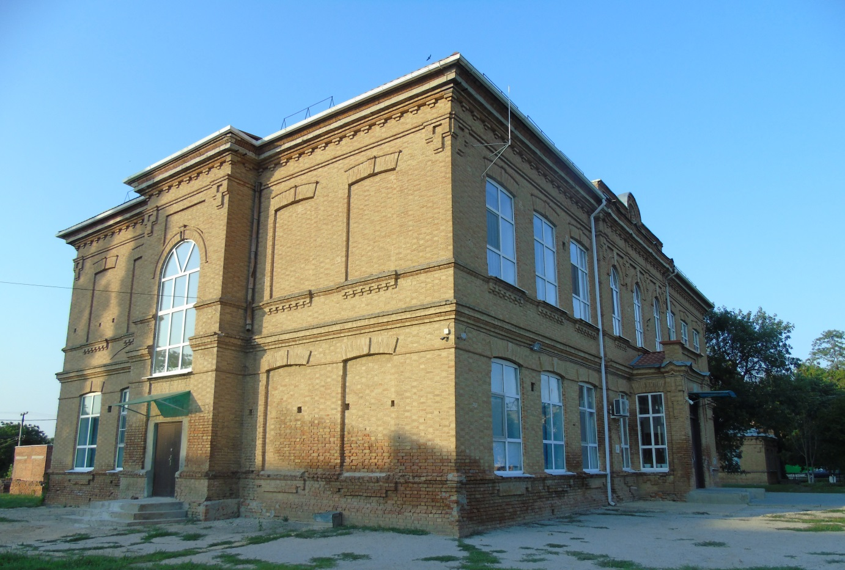
Photo 19 (author E.V. Smola)
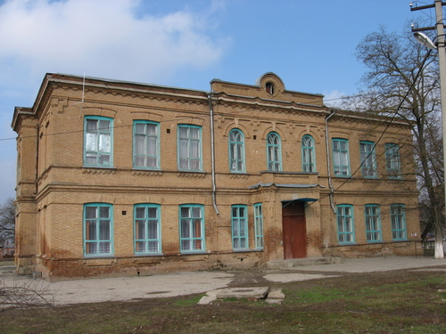
Photo 20. The beginning of the XXI century.
(Archive Department of the administration of the Shcherbinovsky district municipality)
Wing of the Mikhailovsky Higher Primary School
Date of construction:1907. Photos 21-24
Location: near the intersection of Lermontov and Krasnaya streets from Krasnaya St. (legal address: 37 Lermontova St.).
Historical background: It was intended for the residence of teachers of the Mikhailovsky Higher Primary School.
Currently, the building houses the offices of agricultural labor and home economics of MBOU Secondary School No. 1.
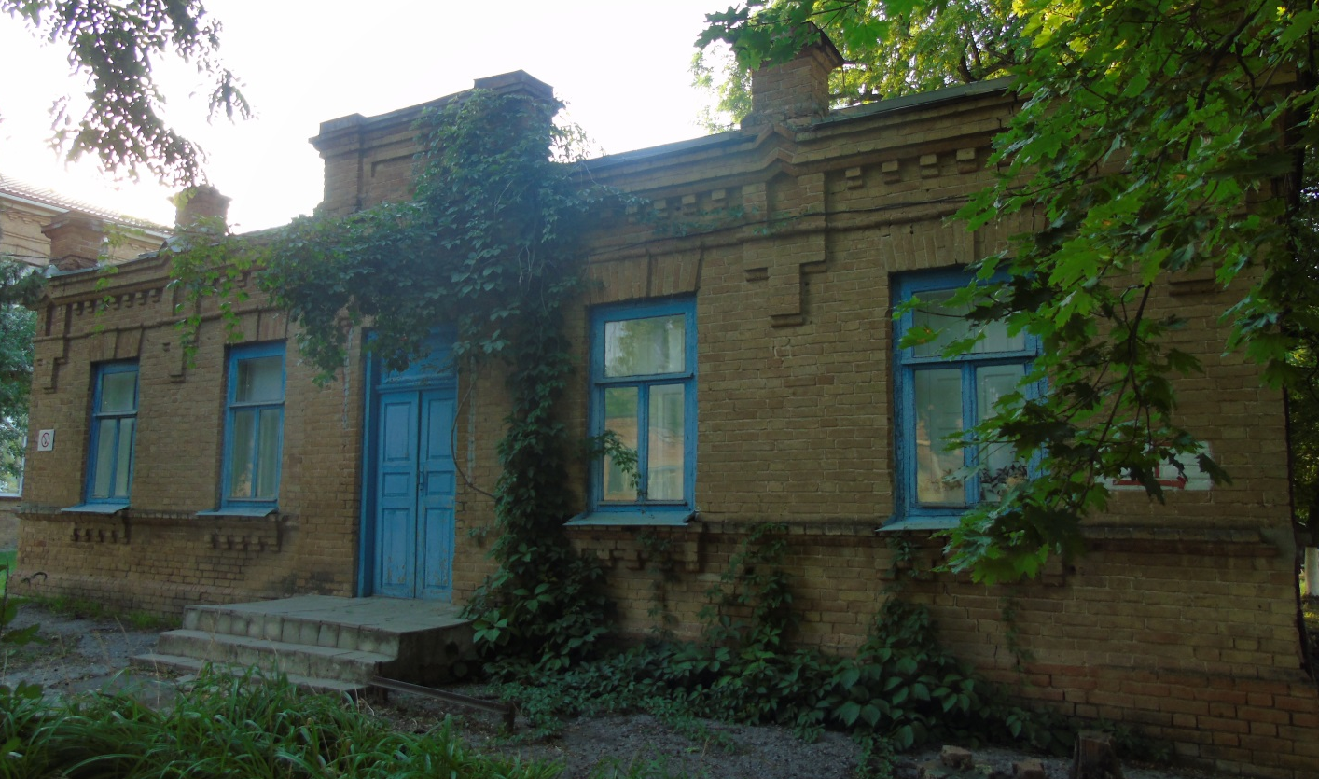
Photo 21 (author E.V. Smola)
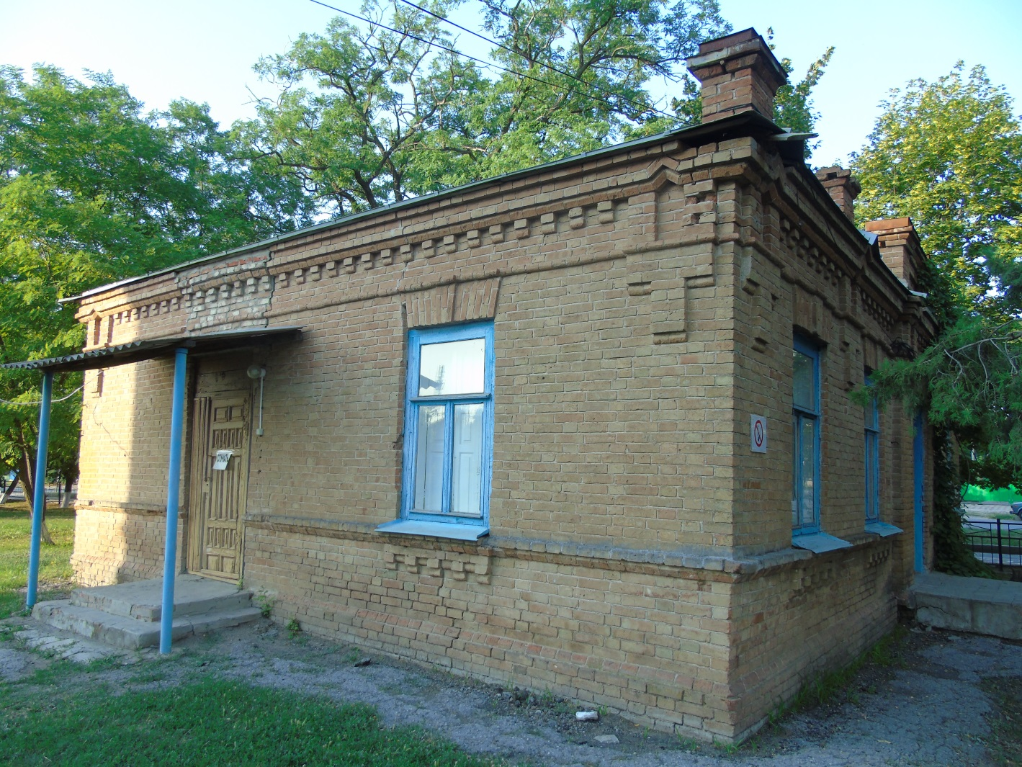
Photo 22 (author E.V. Smola)

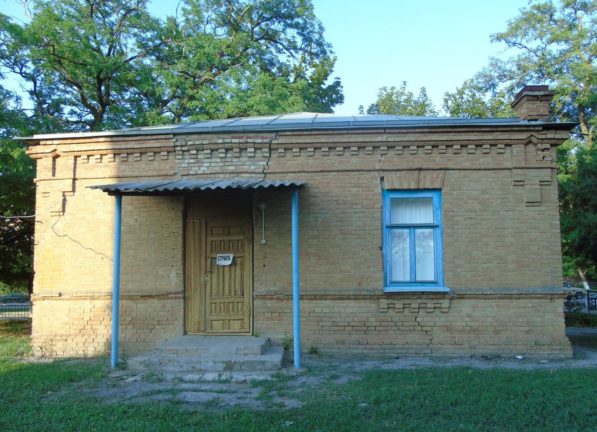
Photo 23 (author E.V. Smola)

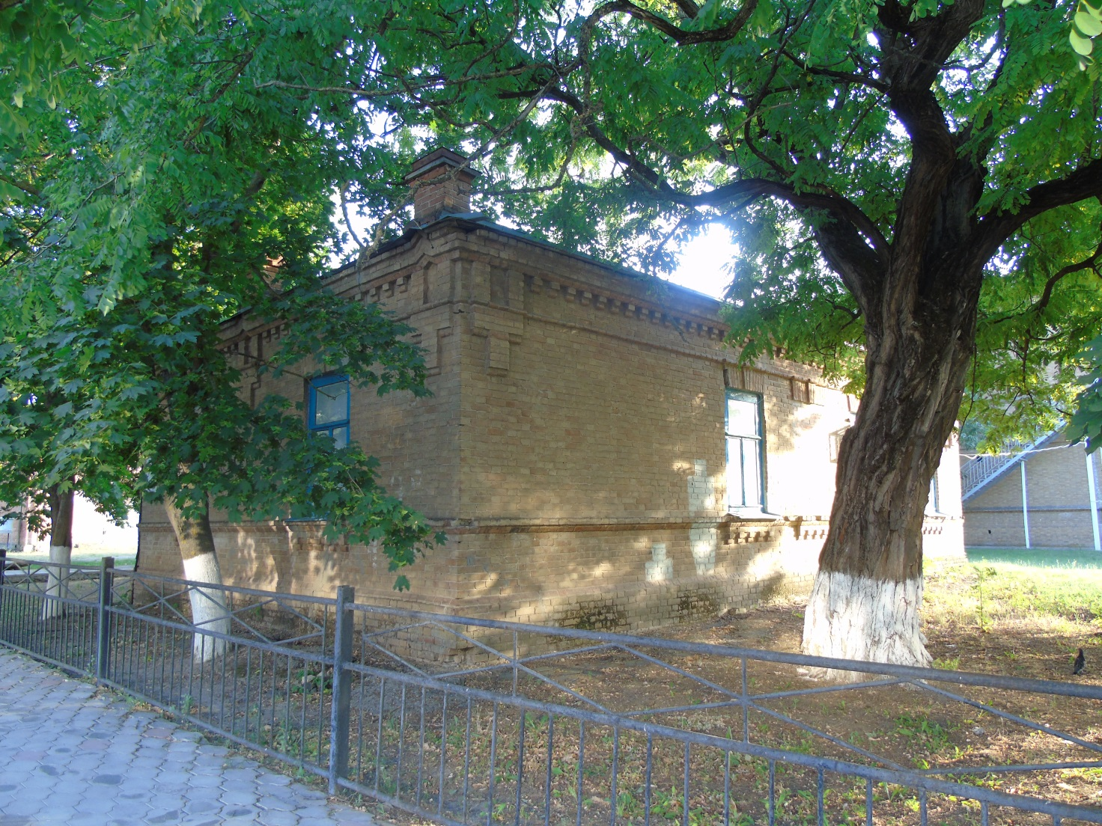
Photo 24 (author E.V. Smola)

Kazak Krikun Household

Date of construction: 1896. Photos 25-30
Location: Soviets, 64, letter A.
Historical background: It belonged to a Cossack named Krikun.
The letters "A. V. K." have been preserved on the front of the building.
According to the stories of local residents, these are the initials of the owner of the house, Alexei Krikun.
We found information from the GACC, which mentions the family of Vasily Iosifovich Krikun-Nechiporenko (see below), who had three sons: Abraham, Job and Athanasius. At the time of the house's construction, Abraham was 61 years old, and Athanasius was 46 years old. Presumably, this house belonged to one of them.
"The Military case
The Black Sea Cossack Army
Family list of residents of the Yeisk military District of Staroshcherbinovskaya stanitsa and clergy for 1863:
661. Vasily Iosifov The Screamer-Nechiporenko, 55 years old, retired,
his sons: Abraham, 28 years old, soldier,
Job, 24 years old, soldier,
Athanasius, 13 years old
Abraham's sons: Mina, 7 years old,
Ivan, 2 years old
Vasily's uncle Peter Stepanov Bondarenko, 62 years old, retired
Vasily's wife Anna, 48 years old,
their daughters: Glyceria, 3 years old,
Onisiya, 2 years old
Abraham's wife Natalia, 22 years old
Job's wife Martha, 17 years old" [13]
Since the middle of the twentieth century, the building has housed a nursery.
At the end of the twentieth century, the municipal police and the passport office.
Currently, BTI (Bureau of Technical Inventory) and the Department of Architecture and Urban Planning.

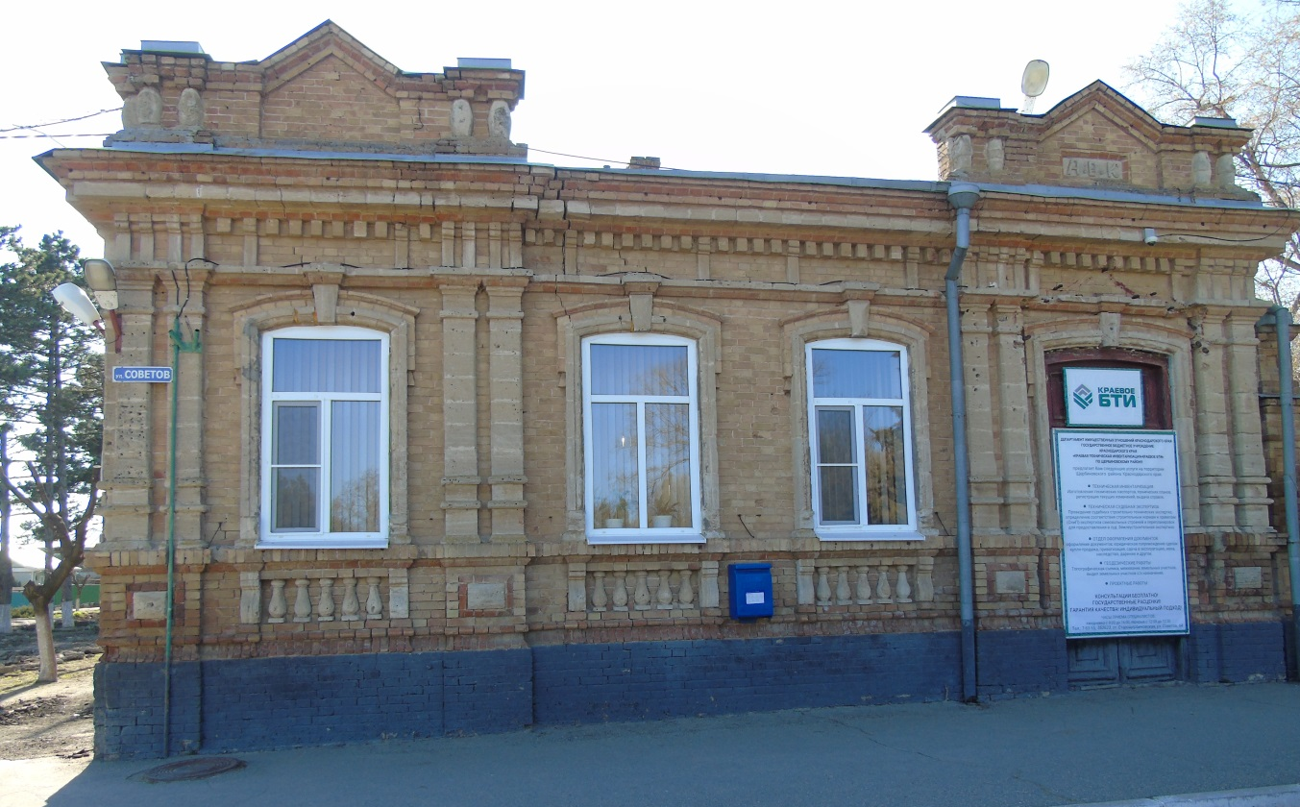
Photo 25 (author E.V. Smola)

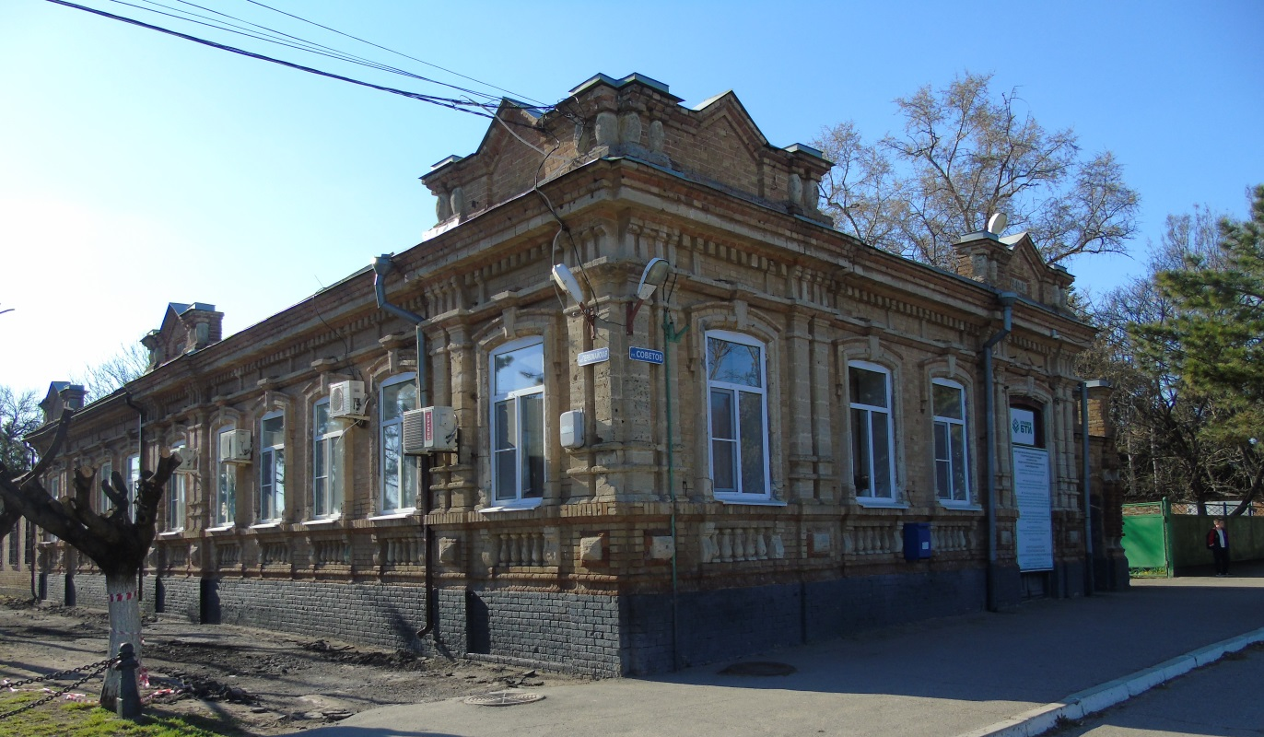
Photo 26 (author E.V. Smola)

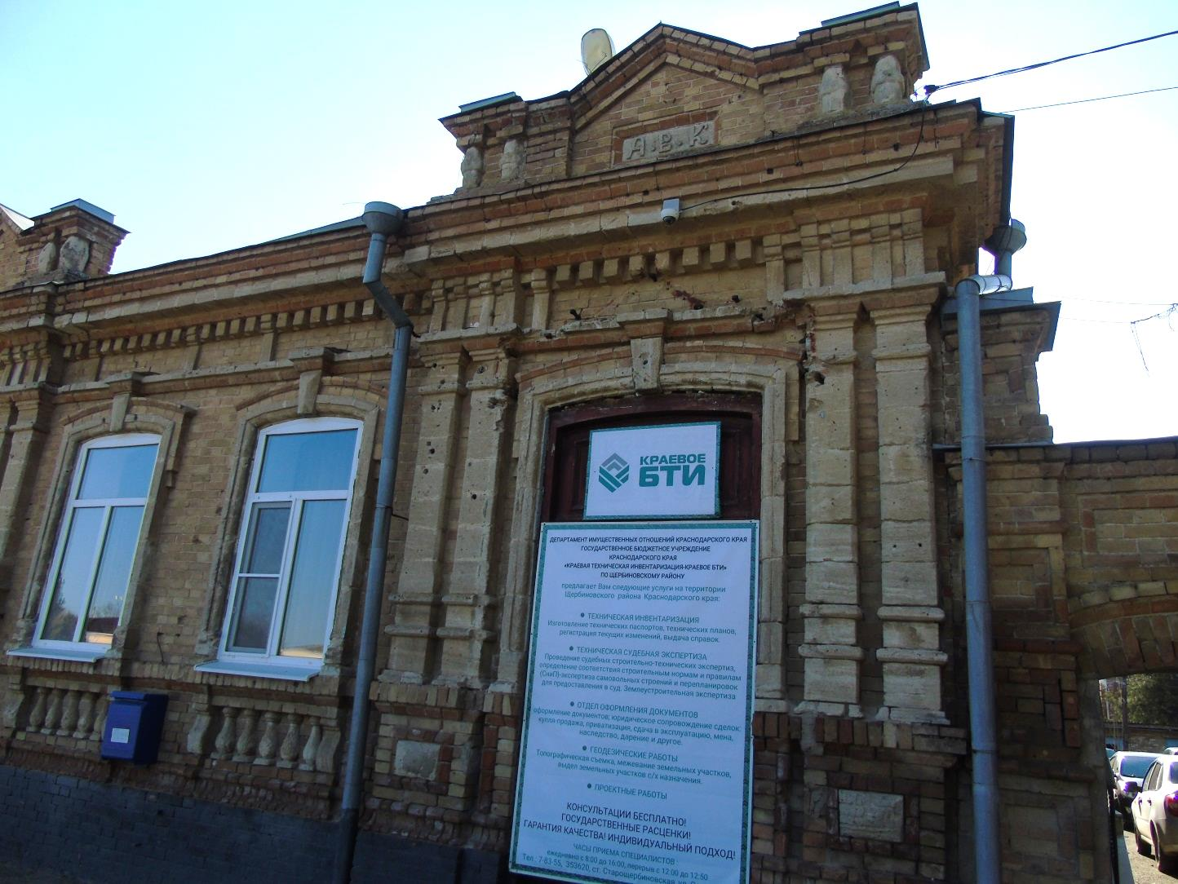
Photo 27 (author E.V. Smola)
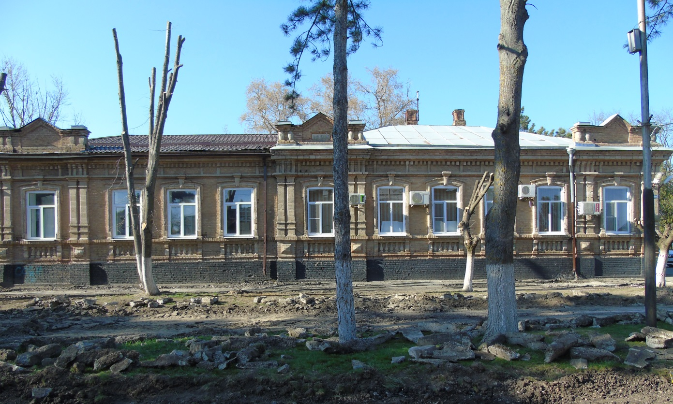
Photo 28 (author E.V. Smola)
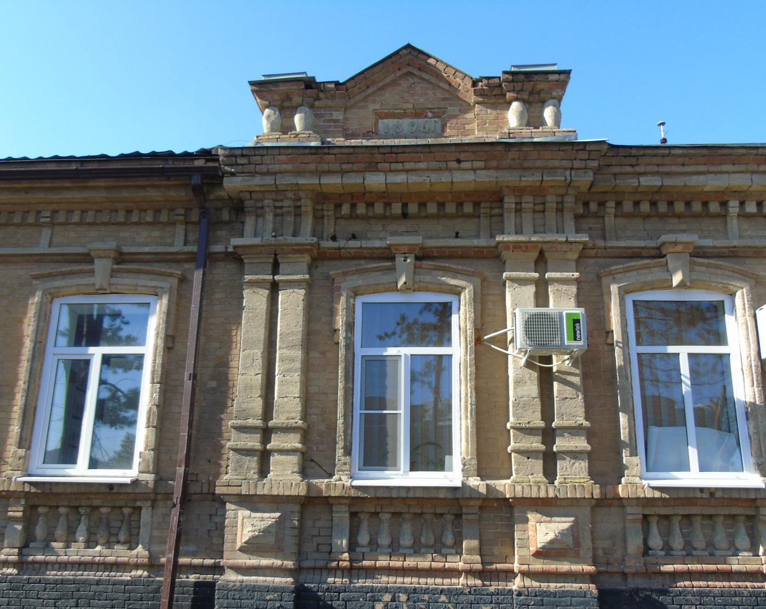
Photo 29 (author E.V. Smola)
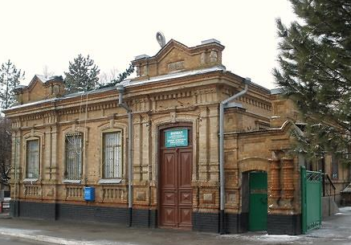
Photo 30. The beginning of the XXI century.
(Archive Department of the administration of the Shcherbinovsky district municipality)
Hospital building/priest's house
Date of construction: 1902. Photos 31, 32
Location: 54 Sovetov Street.
Historical background: Presumably, the building was a hospital of the Cossack army, according to others – the house of the priest Grigory Danilevsky.
In my opinion, the building was a priest's house, as it was located near the Holy Intercession Church, built in 1873 in the center of the village (currently the territory of the park named after the 40th Anniversary of Victory).
An online source referring to GASK reports:
"F.135. Op.55. D.762 About insulting the hymnist of the Church of the Intercession, art. Anthony Chubov's Staroshcherbinovskaya by priest Grigory Danilevsky and about his misconduct 1897-1904" [10]
In the late 1930s, the building was home to the House of Pioneers.
In 1978 – 1982, the savings Bank and the State Bank.
In the early 2000s, he worked as a non-departmental security department.
Currently, there is a Municipal government-owned institution of the Professional Rescue formation "Rescue Service" of the Shcherbinovsky district municipality.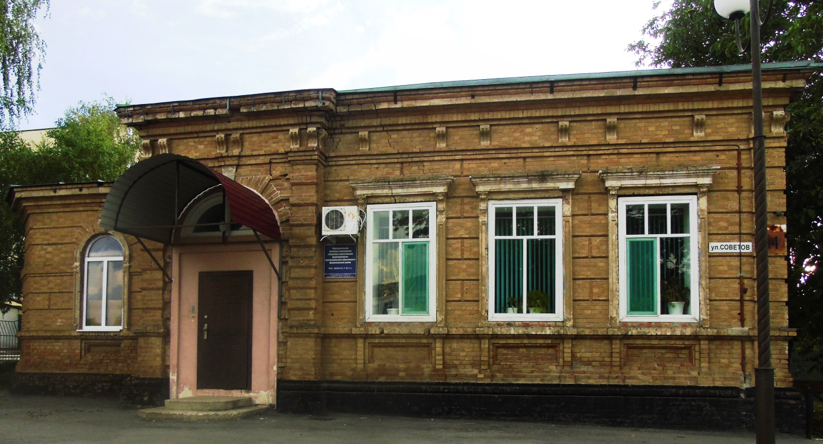
Photo 31 (author E.V. Smola)
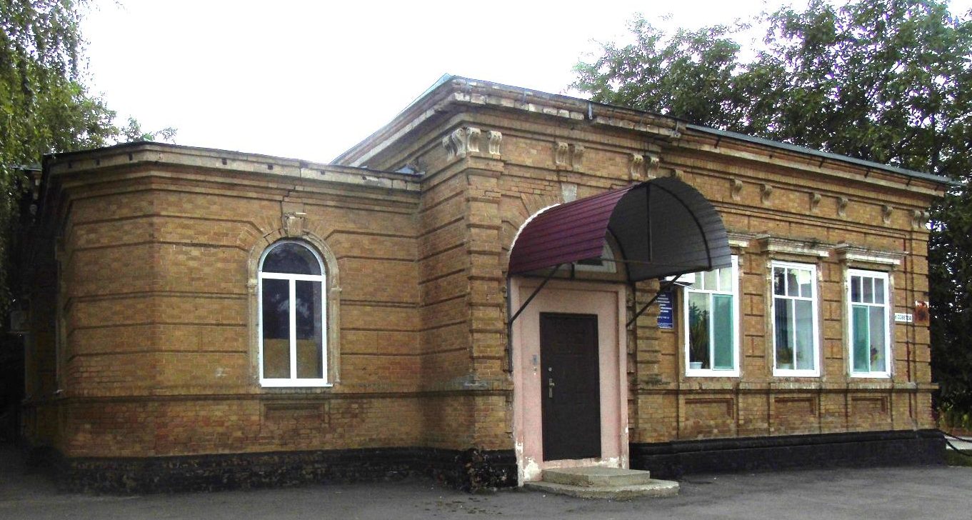
Photo 32 (author E.V. Smola)
The household of the Cossack Krikun (brother)
Date of construction: 1912. Photos 33-37
Location: 66 Sovetov Street.
Historical background: Abraham's brother (Afanasy) Krikun lived here with his family until 1917.
"The villagers were amazed by the beauty of this house. There were sculptures on the brick parapet of the building's facade, and the courtyard was decorated with large vases in which magnificent flowers grew.
After reconstruction in the 2nd half of the twentieth century, the sculptures were destroyed. One of the elements of those ornaments is kept in the Staroshcherbinovsky Museum." [6]
In the twentieth century, there were: the party office, then the All-Russian society "Znanie".
In 1985, the building housed a museum created by Maria Mitrofanovna Pasternak, a history teacher at Secondary School No. 1, back in 1961.
In 1991, the museum was awarded the title of "National Museum of Local Lore", and since 2002 it has been a municipal budgetary cultural institution, the M.M. Posternak Staroshcherbinovsky Museum of Local Lore.
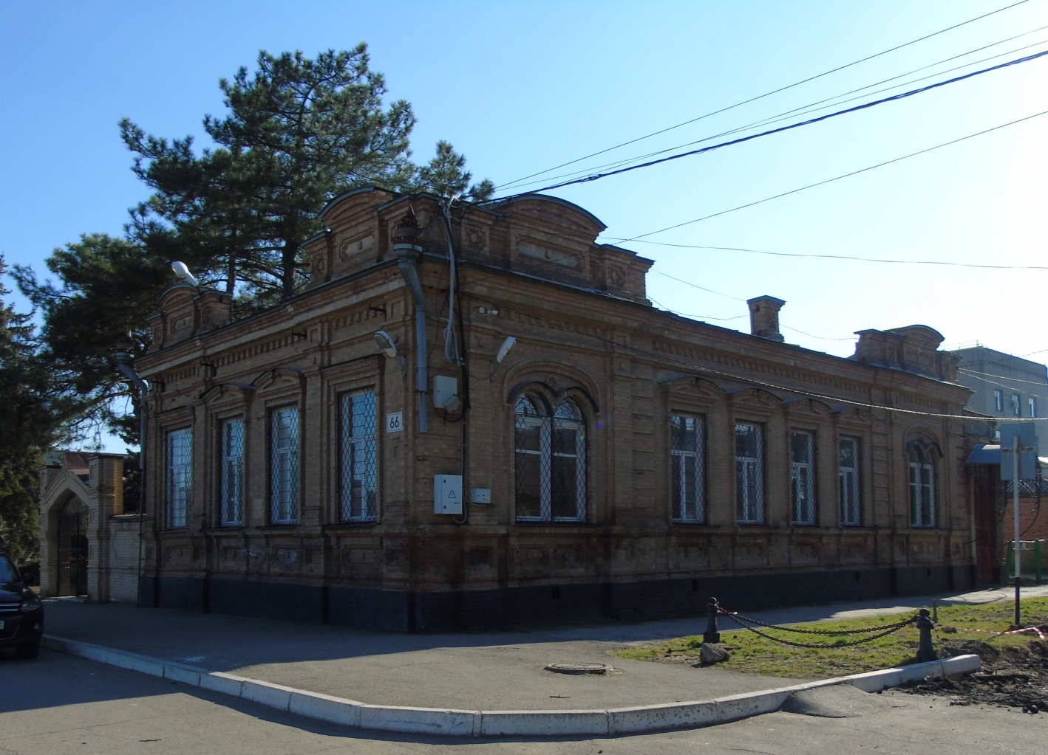
Photo 33 (author E.V. Smola)

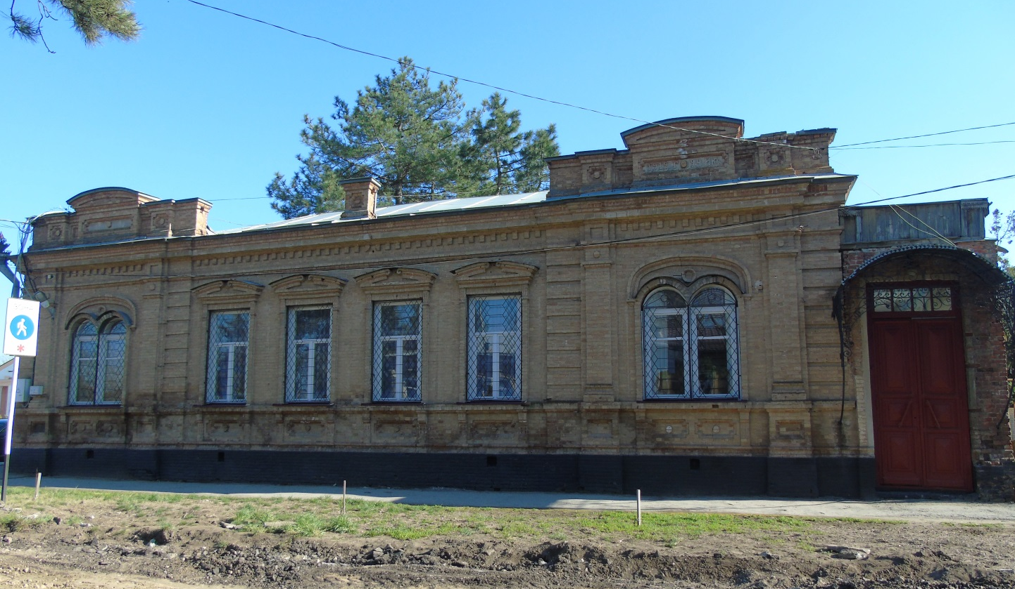
Photo 34 (author E.V. Smola)

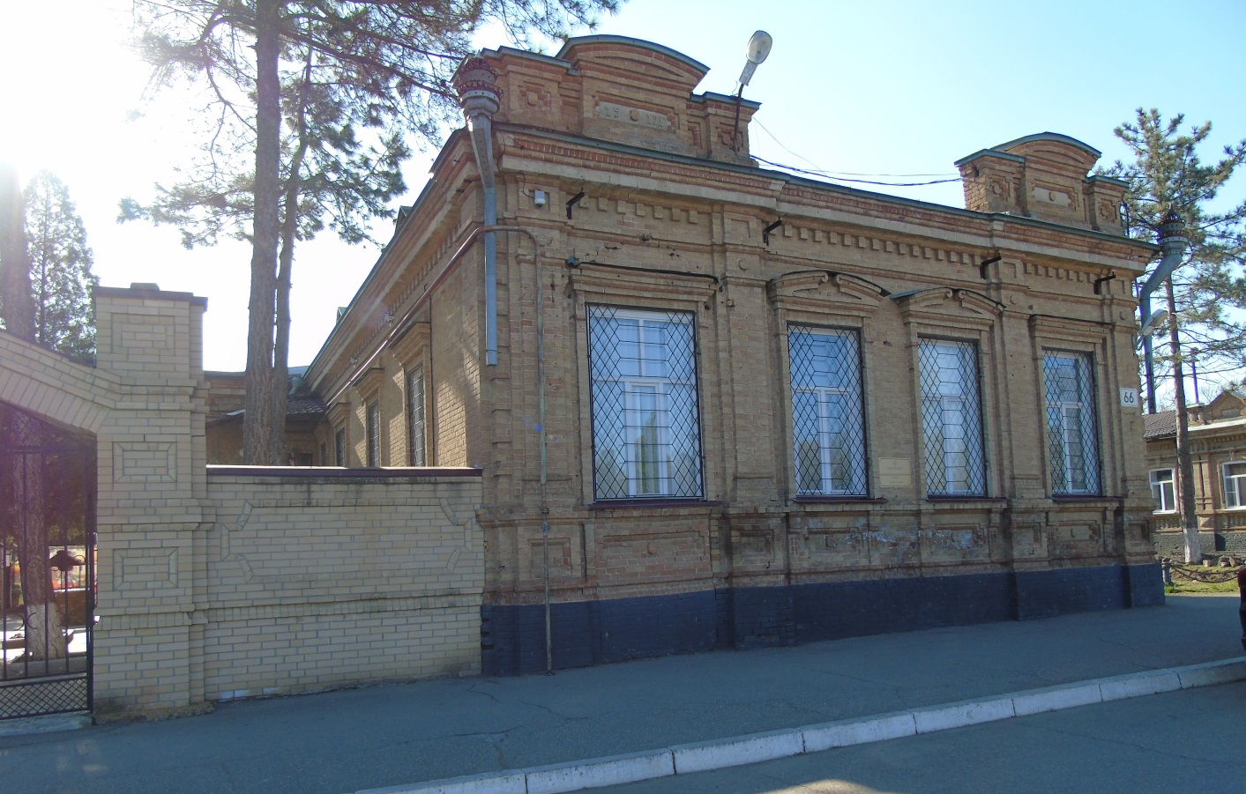
Photo 35 (author E.V. Smola)

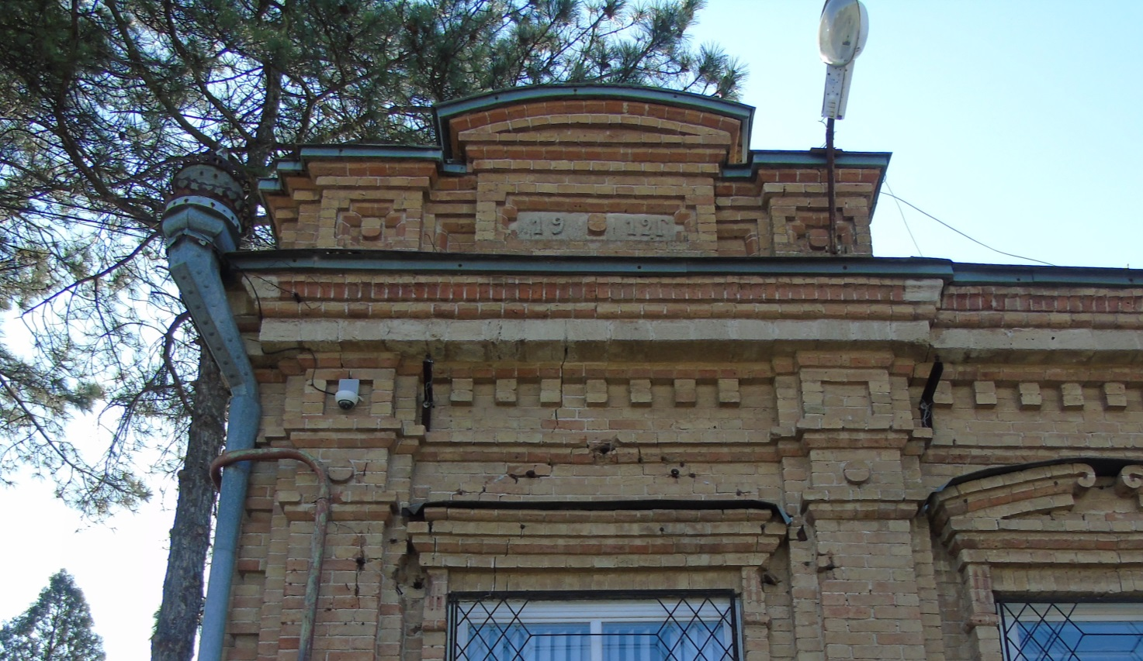
Photo 36 (author E.V. Smola)

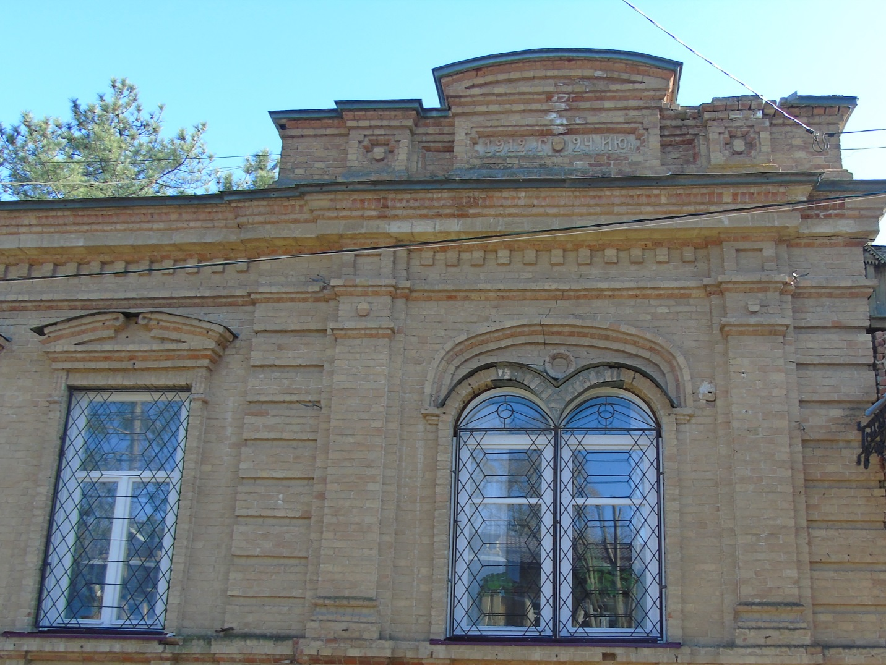
Photo 37 (author E.V. Smola)
Alekseevskoe one-class
men's college
Date of construction: 1902 г. Photos 38-42
Location: Kalinina Street, 59 (originally there were 2 buildings – the second one was subsequently demolished).
Historical background: The newspaper "Kuban Regional Gazette" dated January 18, 1905 reports that on December 13, 1904, in the village of Staroshcherbinovskaya, the newly opened one-class school "in commemoration of the birth of His Imperial Highness Heir Tsarevich Alexei Nikolaevich" was named Alekseevsky by the Highest Command. Also, the village square, on which the school was located, became known as Alekseevskaya. [8]
"The honor of being the first head of the school fell to Fyodor Prokopievich Maltsev. This fact was established from the church metric books of the local Holy Protection Church for 1905. According to the entry in the book, Fyodor Prokopievich Maltsev, the head of the Alekseevsky School, became the godson of one of the village infants baptized in 1905. Teacher Maltsev continued to head the school in 1906. This year, a new addition appeared in the family of Fyodor Prokopievich and Darya Ivanovna - Fyodor was born, as evidenced by the preserved entry in the metric book of the Holy Intercession Church for 1906, indicating the position of his father, the head of the Alekseevsky Ministerial School. Fyodor Prokopievich Maltsev was also in charge in 1907, which is evident from the Certificate of graduation from the Alekseevsky College of our stanichnik Mikhail Timchenko.
Alekseevsky College was never a parish school, but was initially under the jurisdiction of the Ministry of Public Education. Its full name was as follows: Staroshcherbinovskoye Alekseevskoye single-class men's college. Only boys studied there.
The Kuban Calendar for 1908 contains information about the teachers of the school in the 1907-1908 academic year: the head of the school, Alexei Ivanovich Bindar (Bondar?). The Law of God, one of the most important subjects that educated young people in the spirit of Orthodoxy and morality, was taught by one of the full-time priests of the Holy Protection Church, Theodore Bakulin. In addition to the Law of God, the Cossacks learned reading, writing, and arithmetic, and Ivan Terentyevich Dobrobaba and Evgenia Nikolaevna Kravtseva taught these subjects. Singing was taught by Grigory Kirillovich Vaskov, and gymnastics (an analogue of modern physical education and the basics of military affairs) was taught by sergeant Fyodor Lukyanenko.
In 1913, the 8-year-old son of a Shcherbinovsky Cossack, Semyon Grigorievich Skovoroda, entered the first
class of the college. Here is what he later recalled: "... On September 1, 1913, my mother led me by the hand to the school on Alekseevskaya Square. The first-graders are greeted by the head of the school, Ivan Terentyevich Dobrobaba, and our homeroom teacher, Ekaterina Vasilyevna Yatsevilo. After the call, she tells us some fairy tales, shows us how to sit at a desk, how to handle books. I have to wear a blue shirt with a twisted cotton belt and black trousers to school. But getting to school during the long period of muddy weather is difficult. The thick, dark mass of soil, stirred by the feet of horses and passers-by, simply takes off his boots. The best way to travel is on horseback. Many students ride to school in the morning, then the leash is tied around the horses' necks, and they themselves go home. In spring, on Palm Week, all the students go to church for worship. The Intercession Church accommodates all students of several schools. Our school is being built in rows first at the altar. This privilege is due to the name "Alekseevskaya", given in honor of Tsarevich Alexei Nikolaevich... In their studies and in everyday life, the "Alekseevites" tried not to lose the honor of their school...".
Since 1913, Ivan Terentyevich Dobrobaba, who graduated from pedagogical courses in Yekaterinodar, was in charge of the college and taught. When Soviet power was temporarily established in Staroshcherbinovskaya, Ivan Terentyevich became an active propagandist of its ideas, for which he was shot by the White Guards on August 2, 1918.
In the 1916-1917 academic year, in addition to Ivan Terentyevich Dobrobaba, they taught at the Alekseevsky College: the priest of the Church of the Intercession, Theodore Antonievich Chubov (the law of God), since 1911, the teaching family of Jacevilo: Vasily Denisovich with his wife Ekaterina Vasilyevna (nee Chervonnaya). The following is known about them: Vasily Denisovich, cornet of the Kuban Cossack Army, in 1902, after completing the Yerinodar pedagogical courses, having gained experience in other villages, in 1911 he returned to his native Shcherbinovka with Ekaterina Vasilyevna, who had previously graduated with honors from the Vladikavkaz Diocesan college. Both have devoted themselves entirely to educating local children. According to relatives, it is known that during the revolutionary events and the civil war, centurion Vasily Denisovich Yatsevilo served in the White army and was killed by the Bolsheviks. Ekaterina Vasilyevna, who became a widow, was brought by fate to Buryatia. Later, for her fruitful 53-year teaching career, she was awarded
the Order of Lenin, and during the Great Patriotic War she led one of the schools in Ulan-Ude. She was awarded the title of Honored Teacher.
Republic of Buryatia. Ekaterina Vasilyevna is an excellent student of education of the RSFSR, she was repeatedly rewarded with diplomas from the Ministry of Education of the USSR. [14]
Since 1914, there has been a trusteeship at the Alekseevsky College. Among the trustees, as a rule, there were people respected by the village society, not necessarily of the Cossack class, but with wealth. The trustees took care of the financial condition of the school, checked the financial statements of the school: the books of accounts, the school cash register in the fall and spring.
Since 1904, Vasily Antonovich Lagernoi, a well-to-do Cossack respected by society, was an honorary supervisor at the Alekseevsky College (see 19. Household of the Cossack Vasily Antonovich Lagernoi).
Young Cossacks of military age were also trained at the school - 86 people in 1916 [8]. Being called up for service, a Cossack had to be literate. On Alekseevskaya Square, not far from the school, there were reviews of Cossack recruits, the condition of horses and equipment was checked, and here the Cossacks showed their ability to ride horses and cut down vines. Later, in Soviet times, the residents of the village lovingly continued to call the school as before - "Alekseevskaya", because their ancestors studied there and received a thorough primary education for their time. [6]
Later, the buildings were transferred to secondary school No. 2.
One of them was demolished in the late 1960s and early 1970s.
Currently, there is a veterinary pharmacy here.
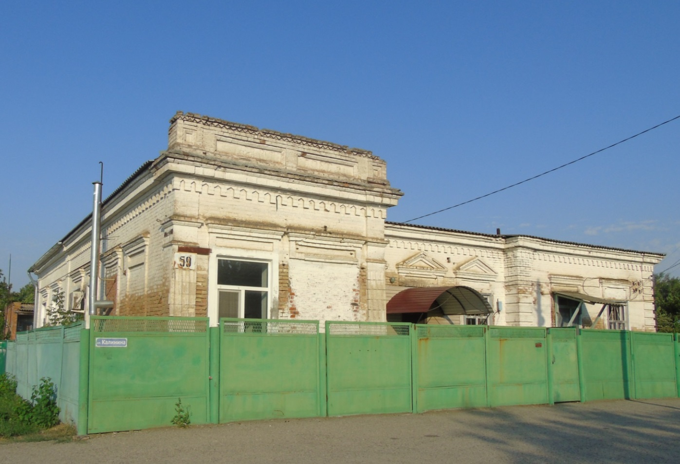
Photo 38 (author E.V. Smola)

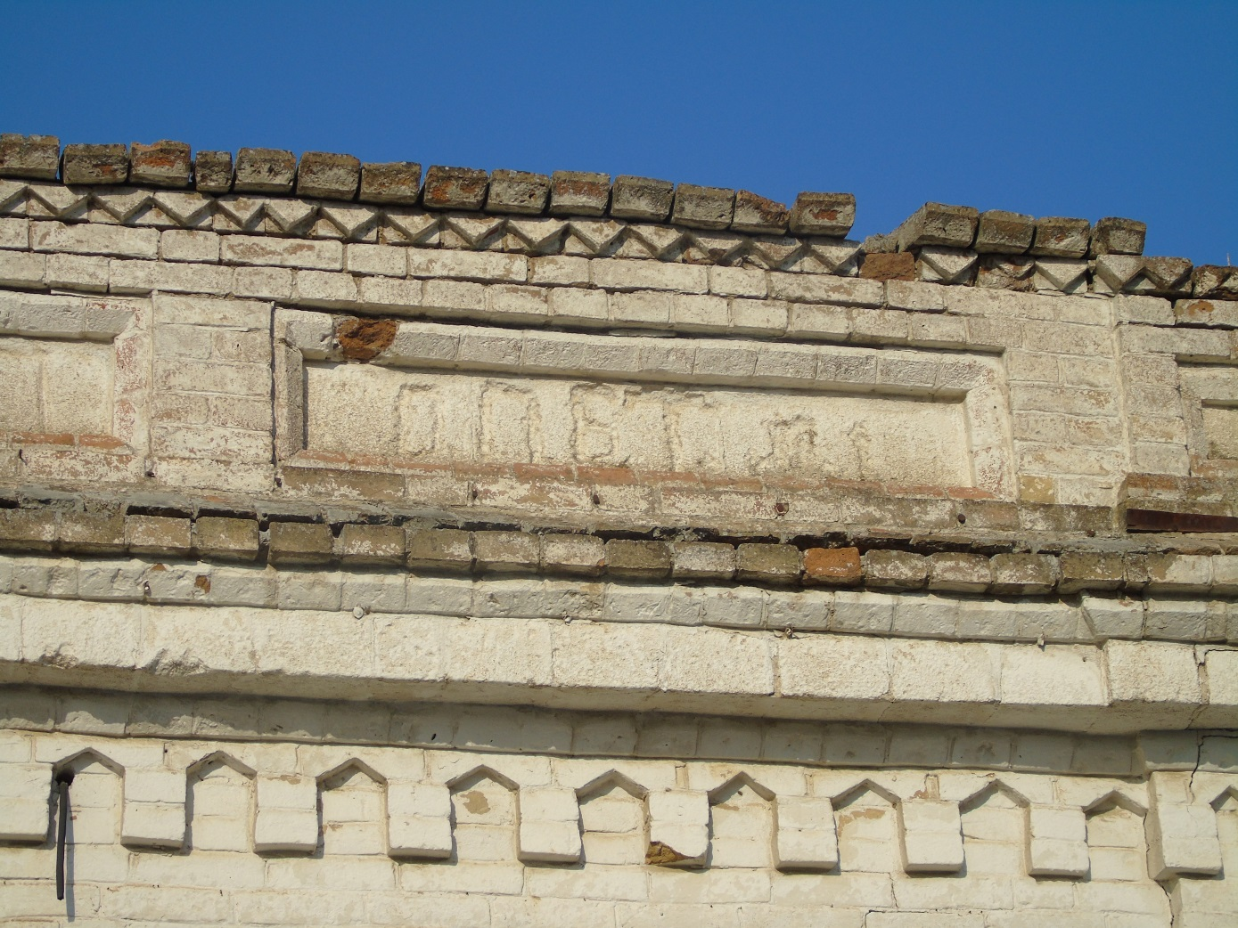
Photo 39 (author E.V. Smola)

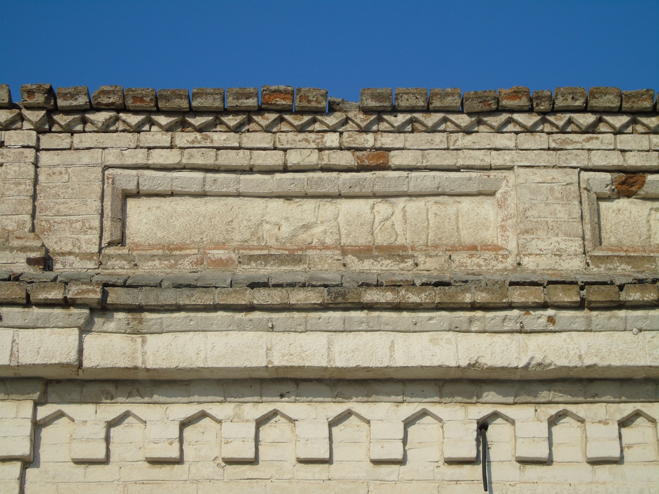
Photo 40 (author E.V. Smola)
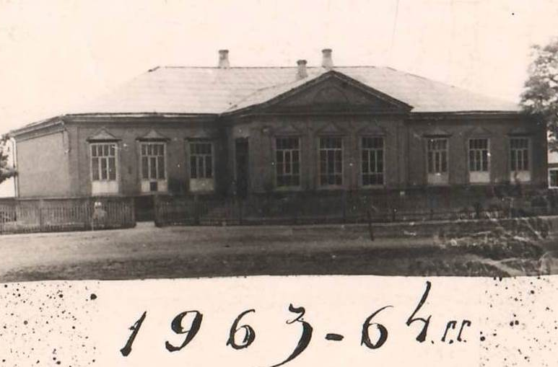
Photo 41 The building was demolished.
(Archive Department of the administration of the Shcherbinovsky district municipality)

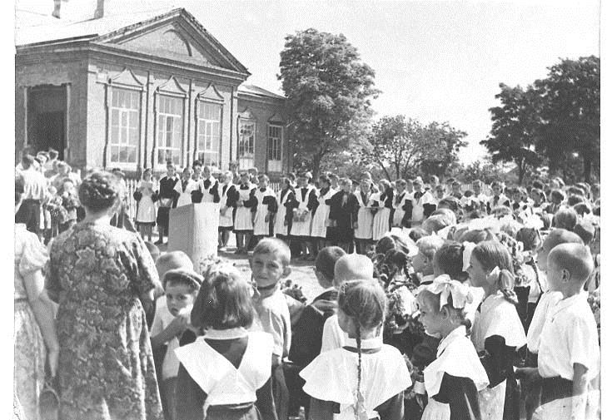
Photo 42. The building was demolished. Photo from the 1970s(Archive Department of the administration of the Shcherbinovsky district municipality)
Stanitsa administration
Date of construction:late 19th and early 20th centuries. Photos 43-45
Location: 69 Krasnaya Street (in the courtyard of the polyclinic).
Historical background: "The opinion of the village society or village assembly was of great importance at that time. The assembly could petition the ataman of the department and the ataman of the order for the release of such and such a Cossack from service for certain reasons or transfer him to another category of Cossacks on benefits. As a rule, the opinion of the assembly was the law for the higher chieftains. In one of the orders for the Kuban Cossack army, we read: "Due to the petition of the assembly of the village of Staroshcherbinovskaya and the Ataman of the Yeisk department, the Cossack groom of the same village Maxim Bely, for excellent behavior and knowledge of his duties in caring for breeding stallions, is renamed non-combatant of the senior category" (123).
Sometimes, after reviewing the cases, the village assembly stood up for the Cossacks of their village, who were punished on active military service in the units of the first stage: "Cossack of the village of Staroshcherbinovskaya of the Yeisk department, Fedor Voloshin, sworn in 1903, who was disciplinarily stripped of the rank of a sergeant by order of the 1st Caucasian Cossack Division of 1909 for No. 141, now in the attention of petitioners for him, both from the village of Staroshcherbinovskaya, as well as the Commander of the 1st Zaporozhian regiment and the Ataman of the Yeisk department, is promoted to the rank of senior constable ..." (124).
So, the village society, having submitted its reasoned conclusion to the ataman of the department and the commander of the 1st Zaporizhia regiment, concluded that Fyodor Voloshin had been unfairly demoted. Therefore, Voloshin, as an innocent victim, was not only restored to his former status by the military authorities, but also given a higher rank. The native village assembly has always been the first and last instance for Cossacks, constables and officers (the Emperor himself was interested in the opinion of the village society in personal Cossack matters)." [Currently, the clinic's laboratory is ocated here.
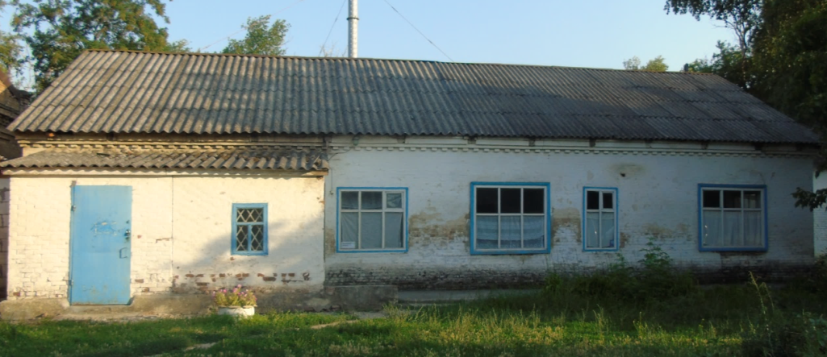
Photo 43 (author E.V. Smola)

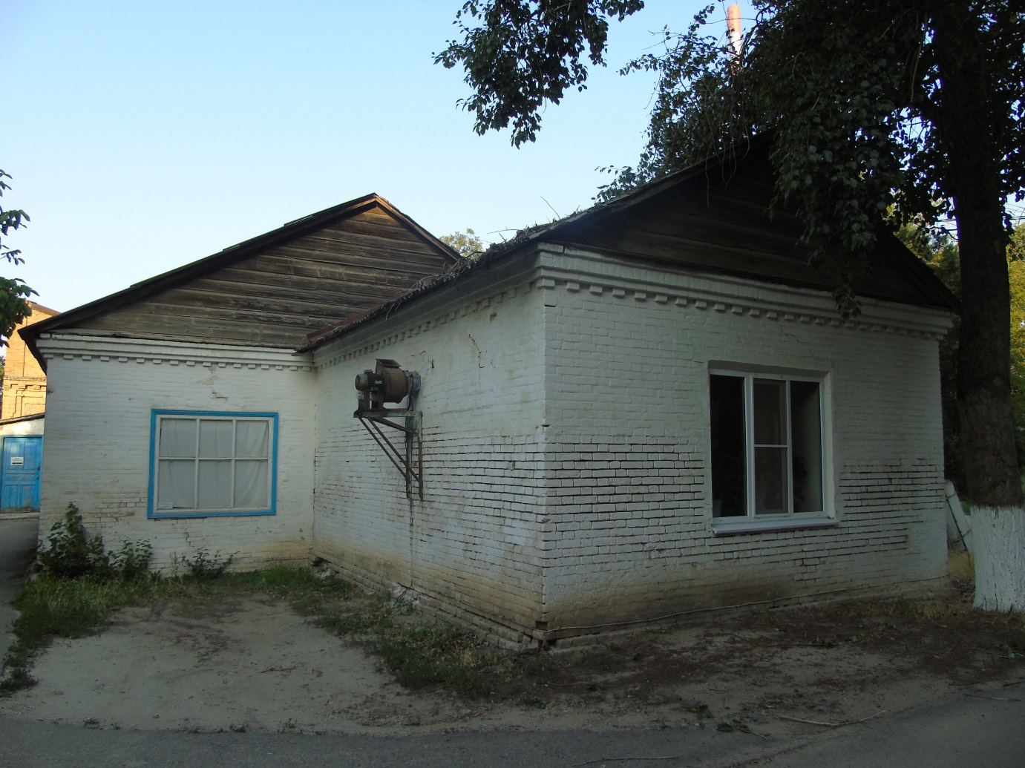
Photo 44 (author E.V. Smola)

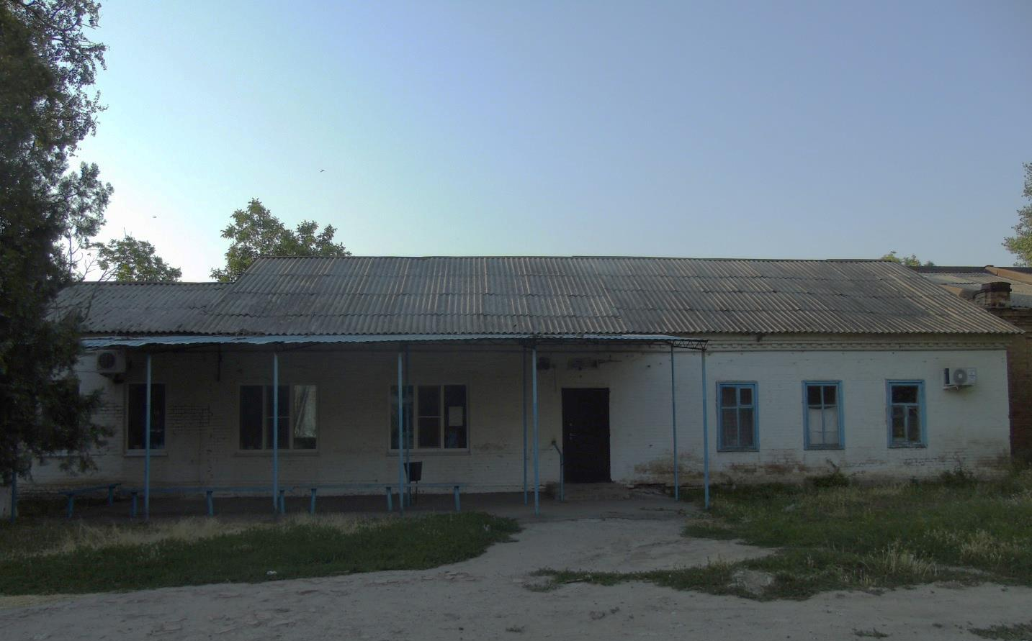
Photo 45 (author E.V. Smola)
Veterinary Service
Date of construction: the end of the XIX – beginning of the XX century. Фото46-48
Location: 69 Krasnaya Street (in the courtyard of the polyclinic).
Historical background: The veterinary service and the stables under the Cossack village administration were located here.
For example, in 1914, Ivan Feoktistovich Lazarevsky, court counselor, worked here as a district veterinarian:
"The Russian medical list
Office of the Chief Medical Inspector
Ministries of Internal Affairs
for 1914
Lists of doctors, veterinarians, dentists, pharmacists and pharmacies, as of May 1, 1914
Government, zemstvo, and city veterinarians by province and region.
Punctual wind. doctor of art. Staroshcherbinovskaya, Lazarevsky I.F.
An alphabetical list of persons authorized to conduct veterinary practice. Lazarevsky Iv. The act. 76 c. 901. with the rank of court counselor of the District. vet. St. Staroshcherbinovskaya, Kuban region. [13]
Currently, the polyclinic's warehouses are located in the building.
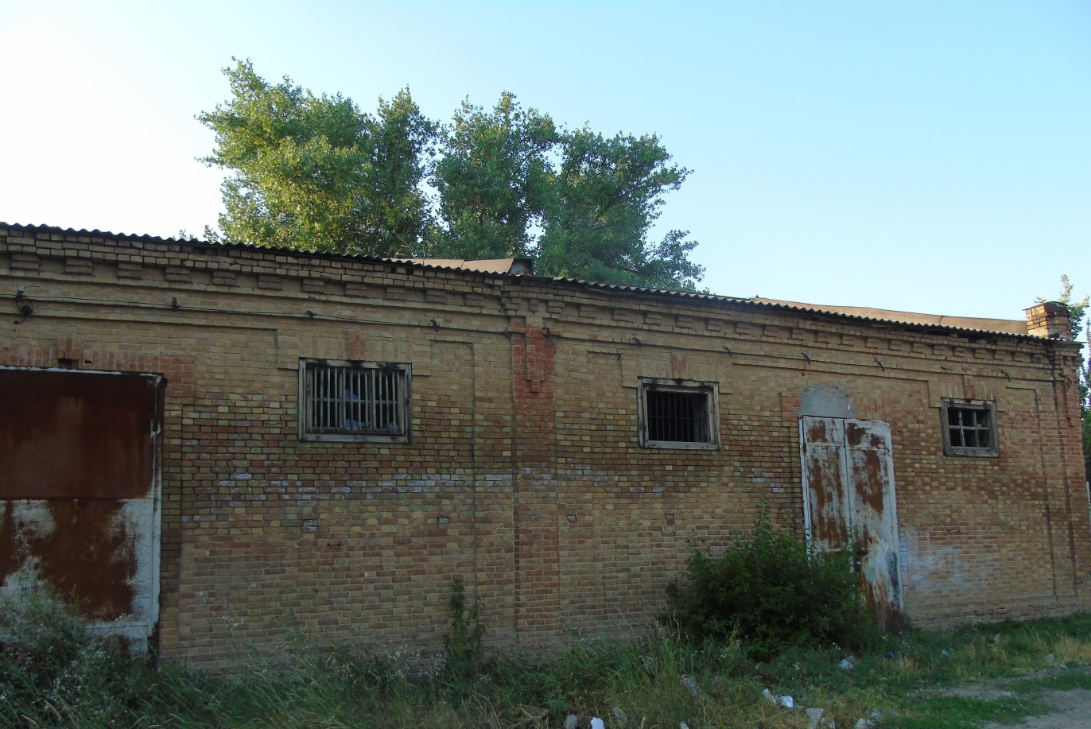
Photo 46 (author E.V. Smola)

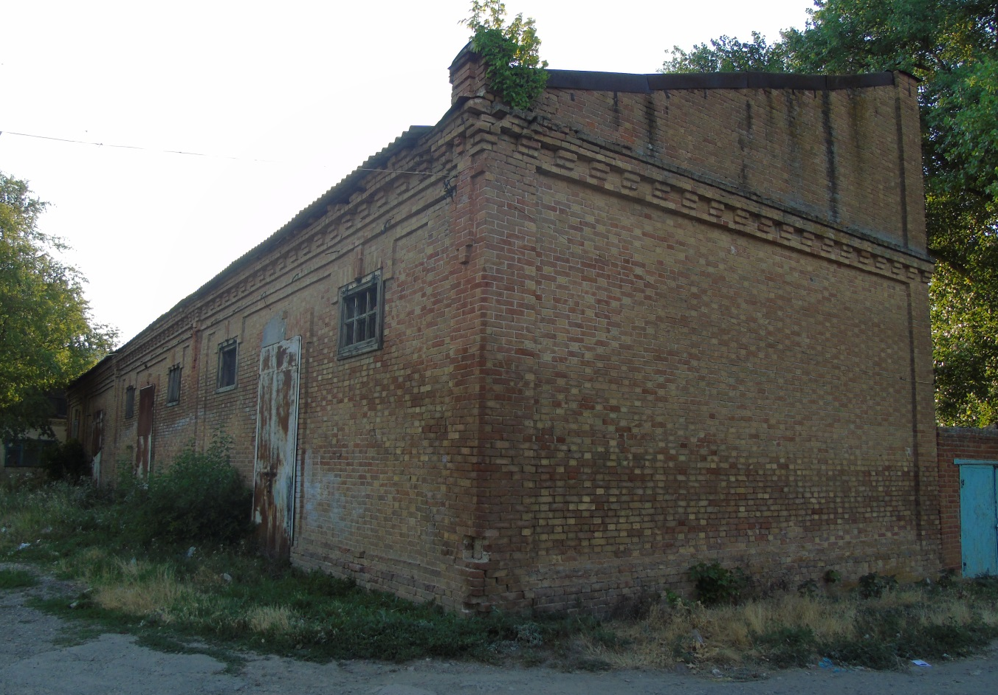
Photo 47 (author E.V. Smola)

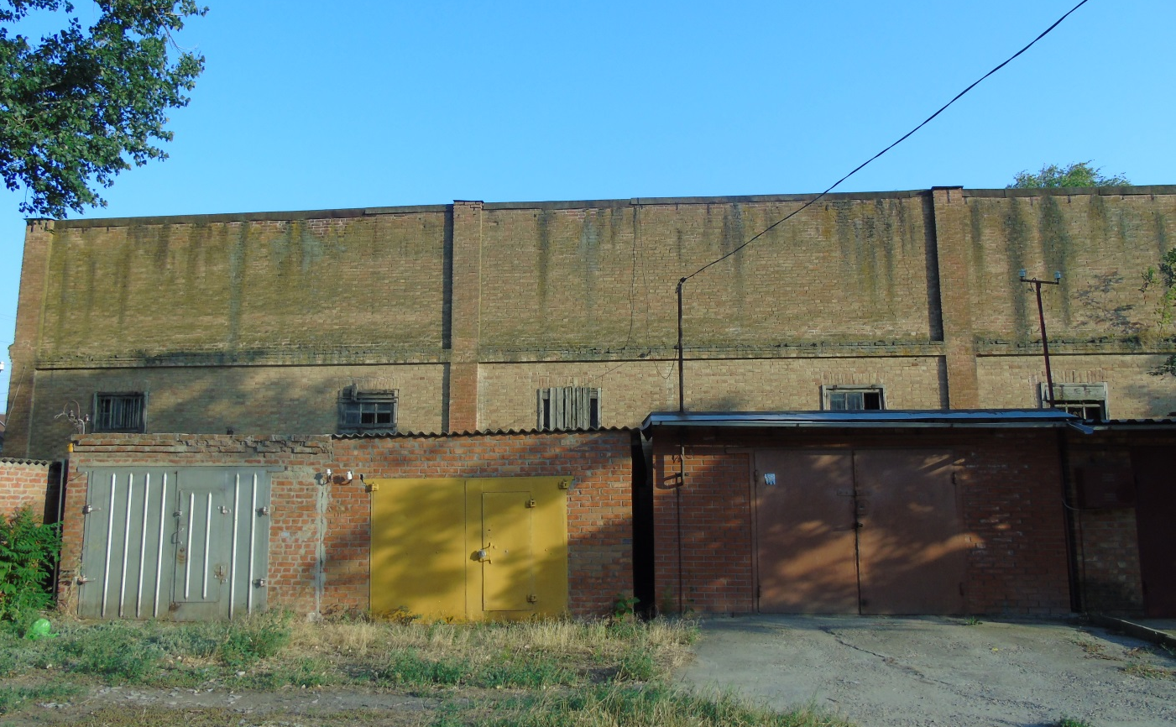
Photo 48 (author E.V. Smola)
Landowner Nazarov's household
Date of construction: 1868. Photos 49-53
Location: on Krasnaya Street, 2 (the intersection of Krasnaya and Stepan Razin streets).
Historical information: It is the oldest surviving building in the village.
It belonged to one of the sons of the Cossack Shcherbinovsky Kuren of the Black Sea Cossack army, Karp Nazarovich Nazarov, a famous Cossack officer who did a lot for the prosperity of his native land (see the Parish School for nonresidents (Nazarov School of Classmates)).
In 1872, it was transferred to the primary school building.
Since the second half of the 20th century, it has been a training and course complex.
Then - the board of the village Cossack society.
The building is currently empty.

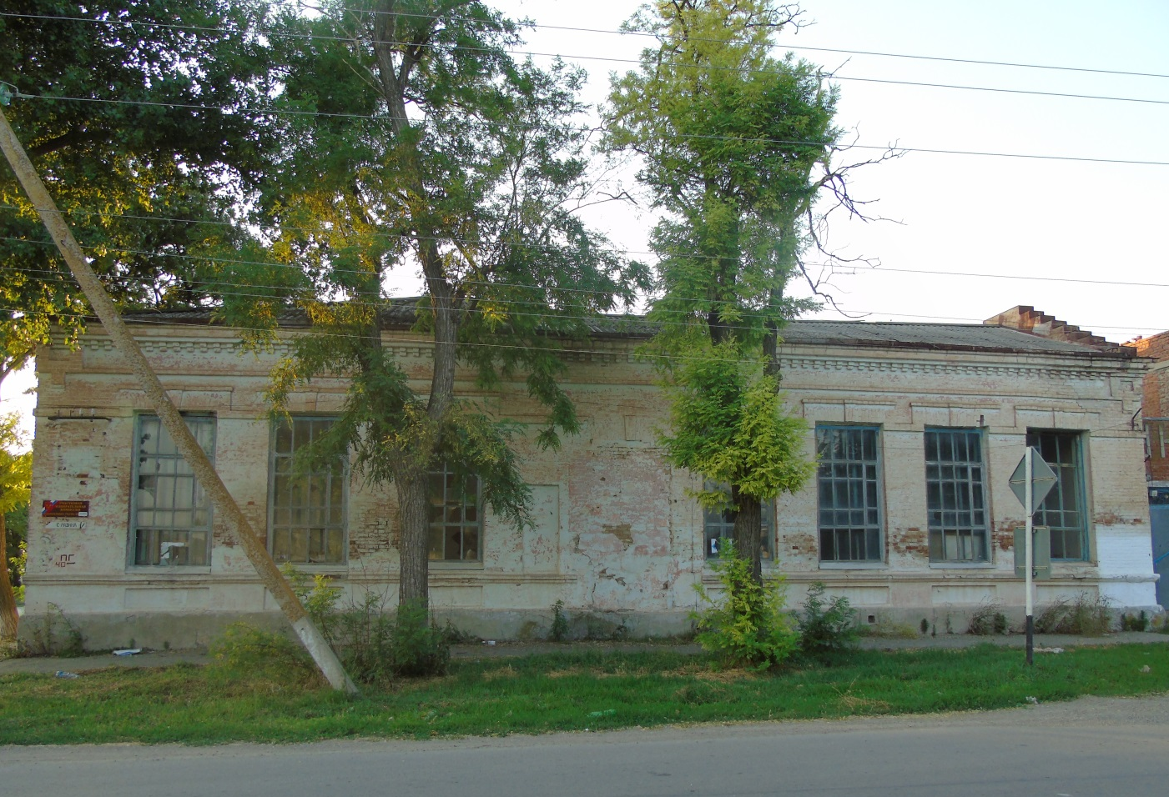

Photo 49 (author E.V. Smola)
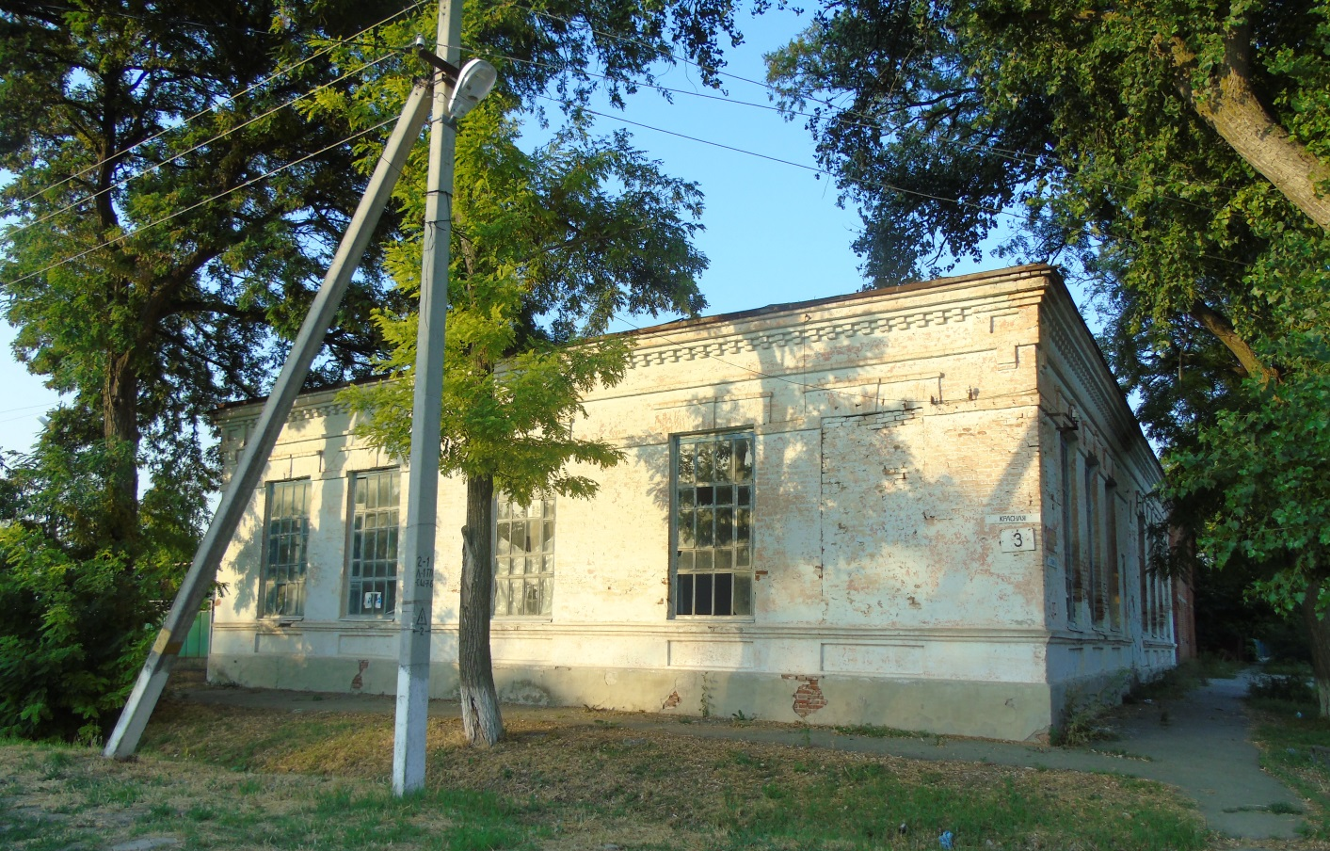
Photo 50 (author E.V. Smola)

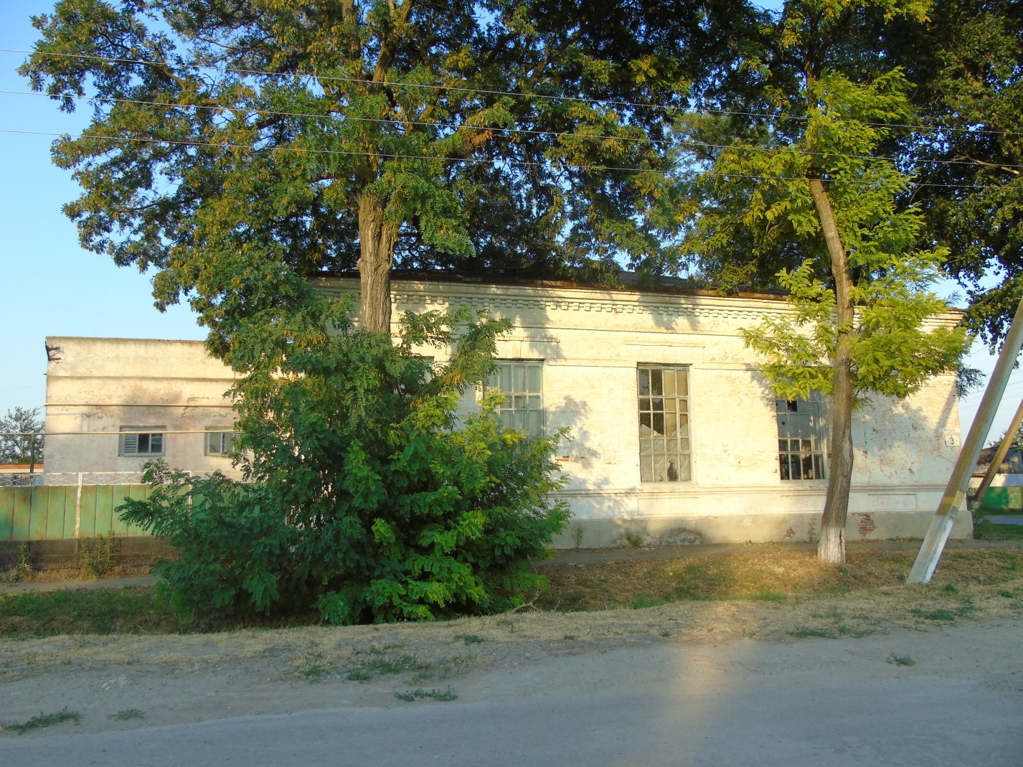
Photo 51 (author E.V. Smola)

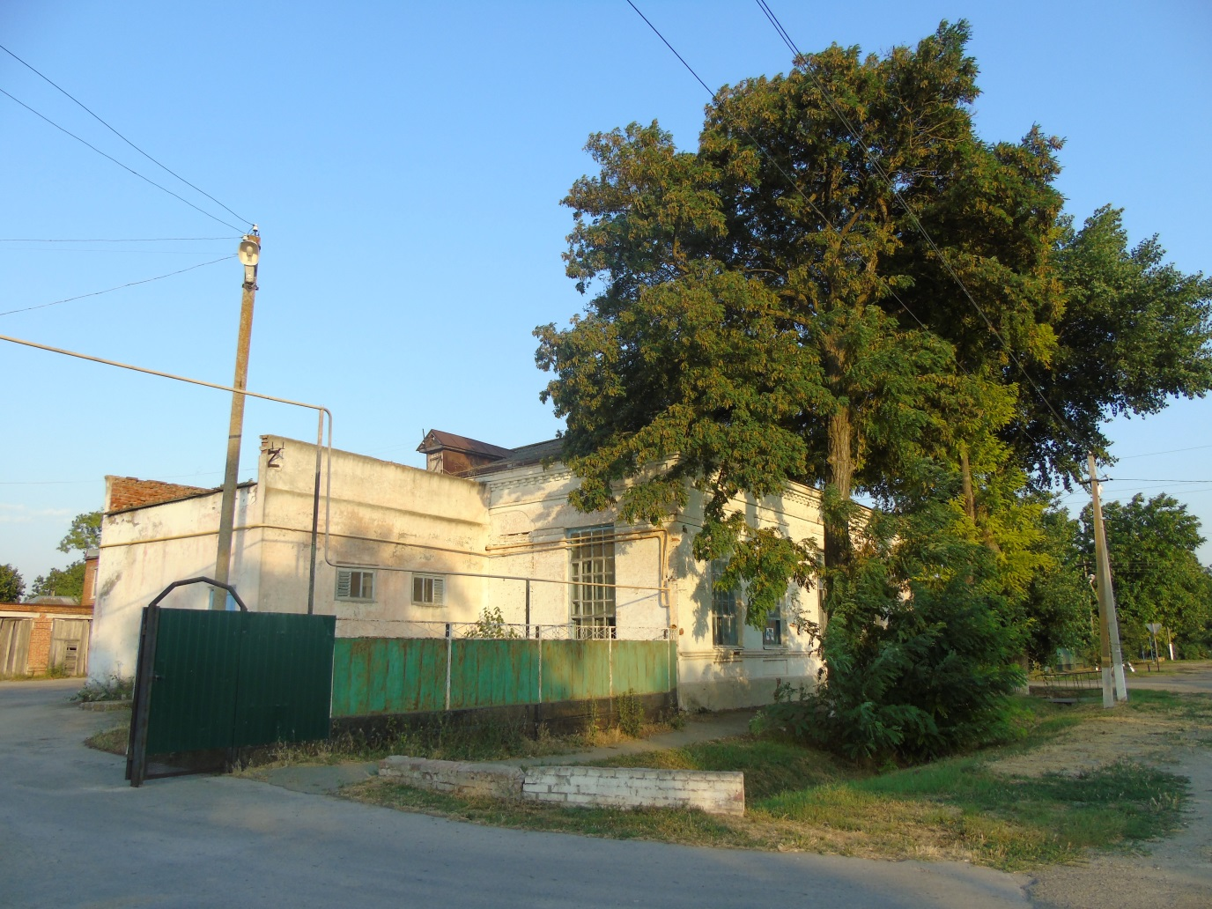
Photo 52 (author E.V. Smola)

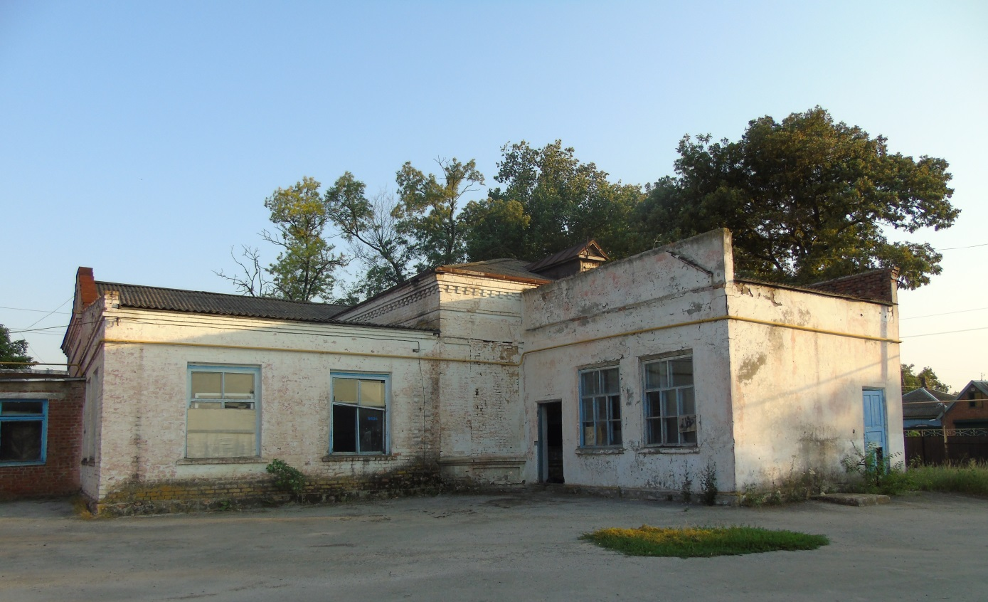
Photo 53 (author E.V. Smola)
The household of the philistine Maltsev

Date of construction: 1905. Photos 54-56

Location: 119 Krasnaya Street.

Historical background: On the pediment, above the entrance door, the letters "P.A.M.". These are the initials of the owner, entrepreneur Prokopy Andreevich Maltsev, a "philistine of Yeysk, Kuban region" (the metric book of the Staroshcherbinovskaya Intercession Church dated October 16, 1893), who was listed as a Yeychanin, but lived in Staroshcherbinovskaya.
A very interesting story related to this house is described in the article "The Mystery of Maltsev" by Yuri Andreevich Skovoroda, a member of the Shcherbinovsky branch of the Russian Society of Historians and Archivists: "After settling in the village, he took up professional repair of mowers, plows and other agricultural machinery." His "... workshops performed turning, locksmithing, and blacksmithing work." Maltsev "was fair and not greedy, regularly paid decent salaries to hired workers. ... It was said that near Maltsev's house, on a fence, on a special shelf, there was always a mug and a barrel of water... - ... a manifestation of the owner's respect for every traveler."
After the 1917 revolution, Maltsev's entire real estate was collectivized, and he disappeared without a trace. However, shortly before the Holodomor of 1933, Maltsev, exhausted and pitiful, was brought under escort from several policemen to his former home, where the arrested were shown the place of a once-buried hiding place - a metal pipe filled with gold coins. "Having poured out the money, leaving the hole and the pipe uncovered nearby, the guests quickly left." [15]
After a while, "... local police officers appeared with the question: "Who was here?" That's when everyone thought that the current police officers were genuine, and those before them were Maltsev's accomplices in disguise." However, the eyewitnesses were not absolutely sure of these conclusions, and this story was passed from mouth to mouth for a long time "... with regret that it is impossible to establish the truth." But, many years later, the author of the article still learns the truth from his relatives.

At that terrible time, the time of the Holodomor, when millions died of exhaustion across the country, Yu's mothersSkovoroda, then still 12 years old, was lucky – she was accepted into her family by her father's sister, whose husband was a "nonresident" and once worked as a turner for Prokopy Maltsev, and was respected by him. The family "... was allowed to leave for Donbass from a cold, dead village." It turned out that Maltsev, who was not the last person at one of the Donbass mines, helped his friend's family to settle down and survive.
When the family was able to return to the village, Maltsev's secret remained unsolved – the times were like this: "If everything had come out, he would have been in trouble, that's for sure."[16]
Based on the analysis of the information collected, it can be assumed that Prokopy Andreevich Maltsev's son, Fyodor Prokopievich Maltsev, was the first head of the Alekseevsky Primary School (see 3. Alekseevsky Primary School).
Since 1939, the building housed the board of the collective farm. Voroshilov.
In the middle of the twentieth century, the incubator of the SEC (collective farm) "Lenin's Banner".
Currently, it is a store of the SEC (collective farm) "Lenin's Banner".
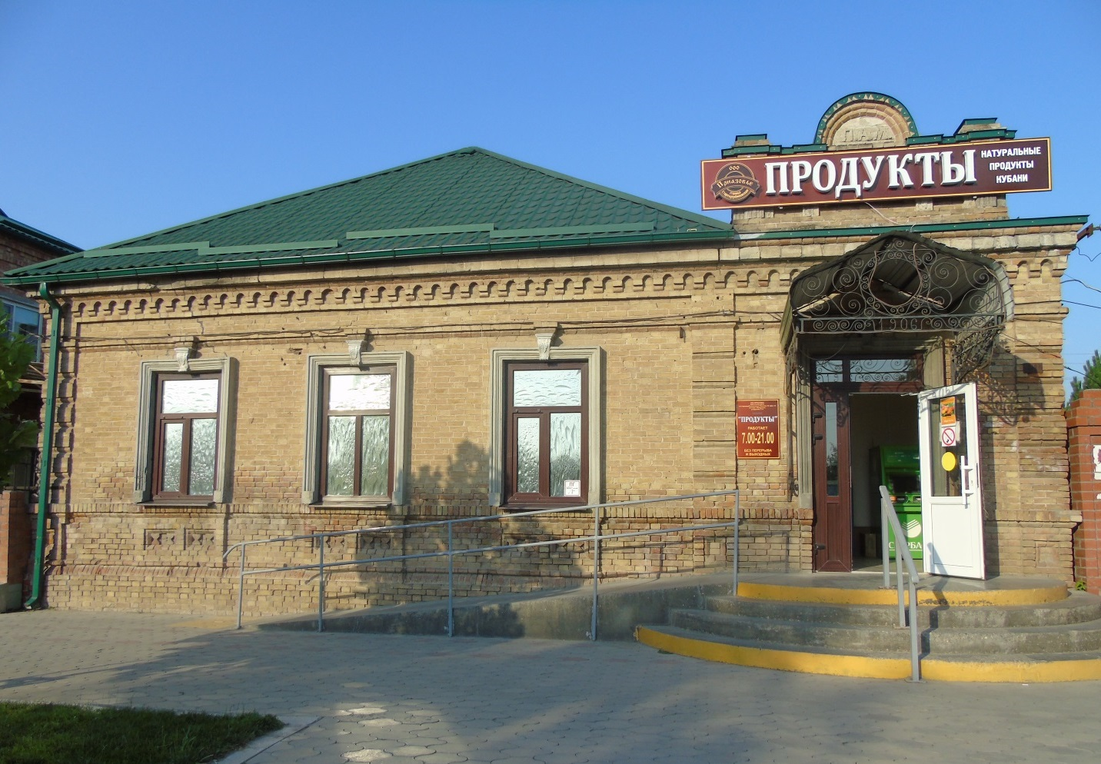

Photo 54 (author E.V. Smola)
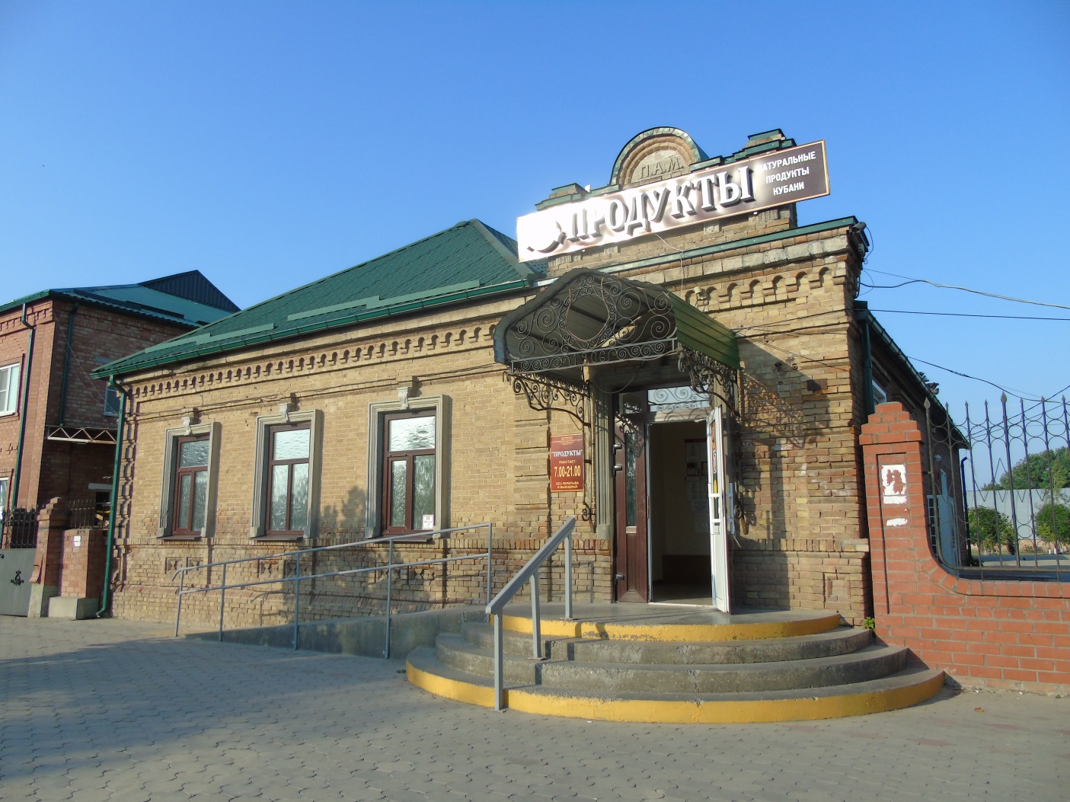
Photo 55 (author E.V. Smola)

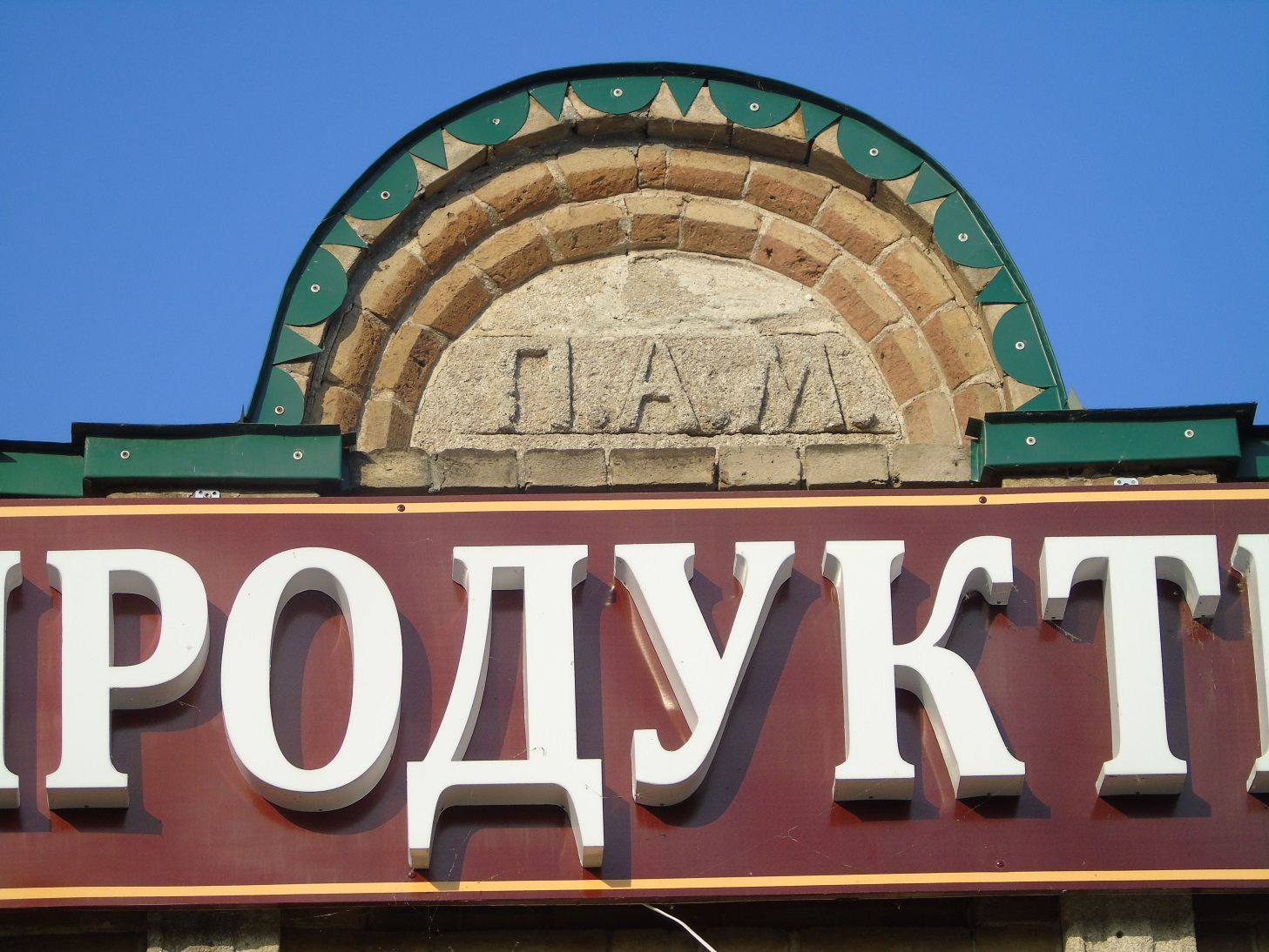
Photo 56 (author E.V. Smola)

Merchant Shamray's household

Date of construction: 1905. Photos 57-59

Location: 52 Lermontov Street.

Historical background: The owner is a grain buyer, merchant Shamray, who lived here with his family until 1917.
From 1915 to 1917 he was an honorary curator of the Staroshcherbinovsky parish one-class boys' school.
The District Prosecutor's Office is currently located in the building.

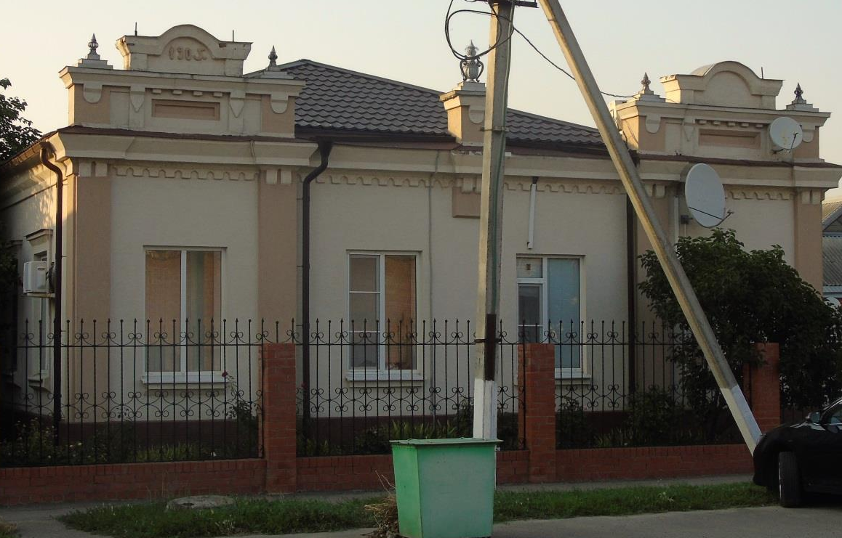

Photo 57 (author E.V. Smola)
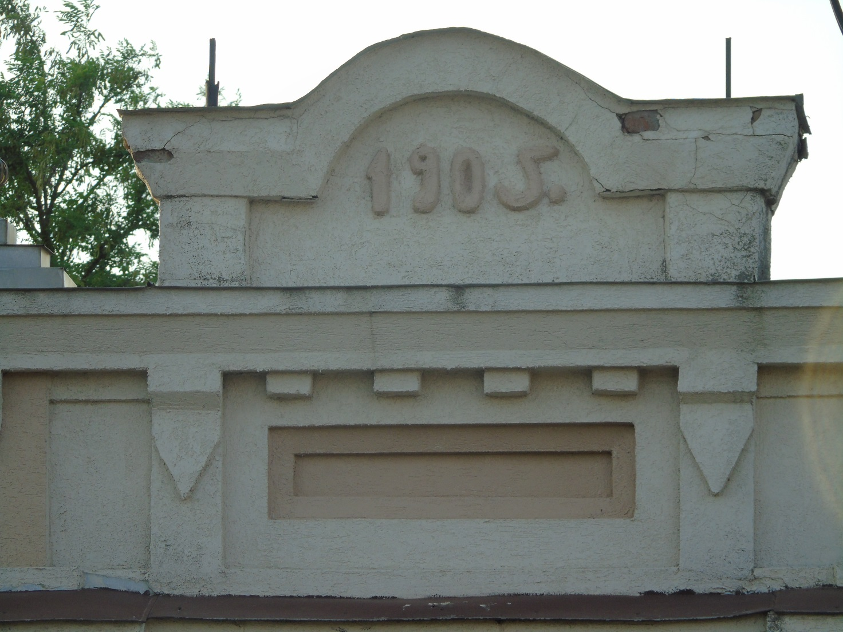
Photo 58 (author E.V. Smola)

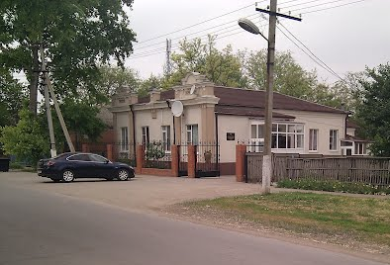
Photo 59 (author E.V. Smola)
Kazak Yaroshevich's household

Date of construction: 1905. Photos 60-64
Location: 25 Sovetov Street (at the intersection of Sovetov and Karl Liebknecht streets).
Historical background: The private house of a Cossack named Yaroshevich, built in 1905, where he lived with his family until 1917.
In the materials of the website "KUBAN GENEALOGY", in the section "Art. Staroshcherbinovskaya" contains a photograph (from the funds of the state archive of the Krasnodar Territory) of Nikolai Nikitich Yaroshevich, a plastun of the 7th Kuban Plastun battalion, who was born on November 17, 1896 in St. Petersburg.Staroshcherbinskaya street. [17] Perhaps this person was a relative of the owner of the household.
After the establishment of Soviet power in 1918, a school was located in the building.
Since the middle of the twentieth century, the building belongs to the Department of the Ministry of Internal Affairs of Russia in the Shcherbinovsky district.
Currently, after the renovation work, the historical appearance of the building has been completely lost.
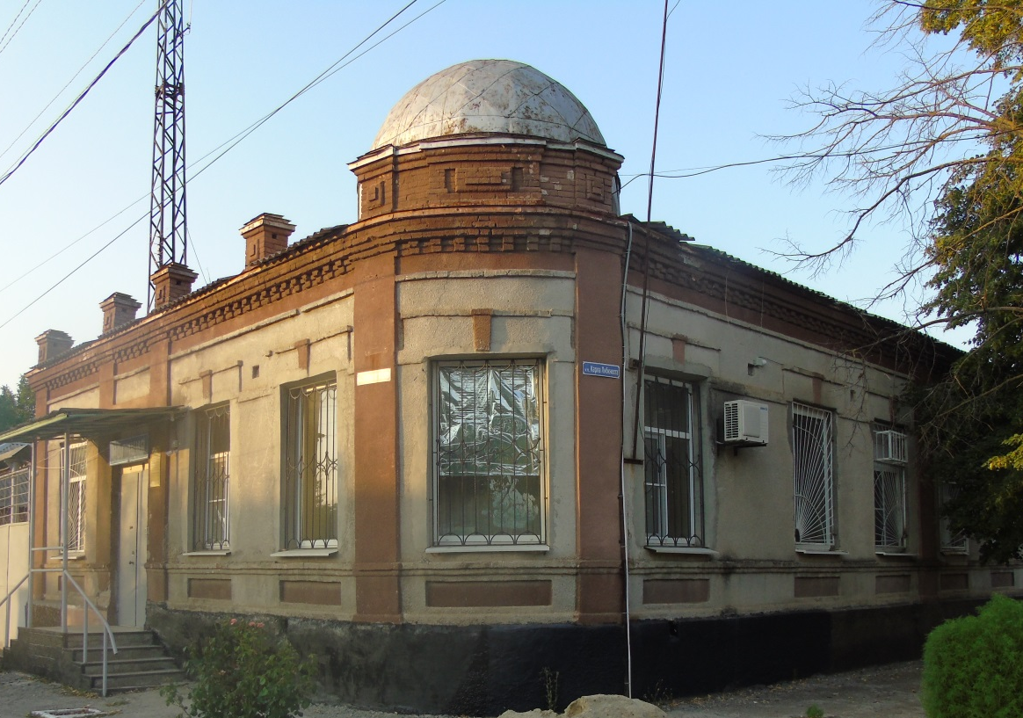
Photo 60 (author E.V. Smola)
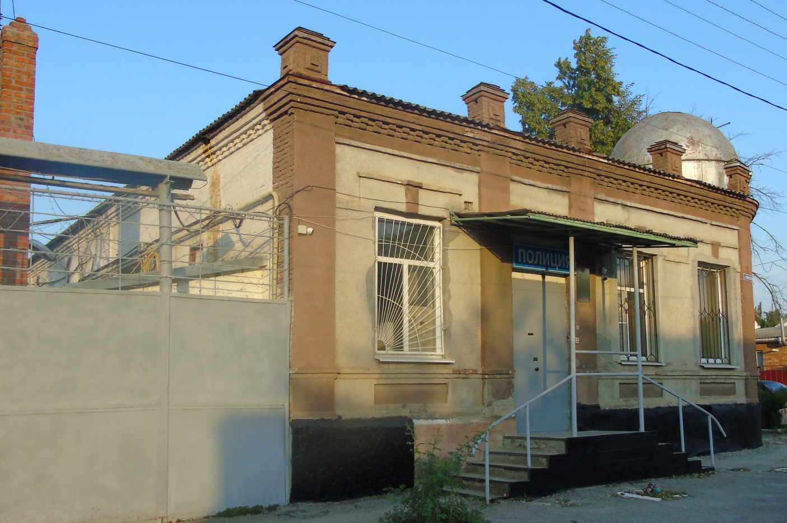
Photo 61 (author E.V. Smola)

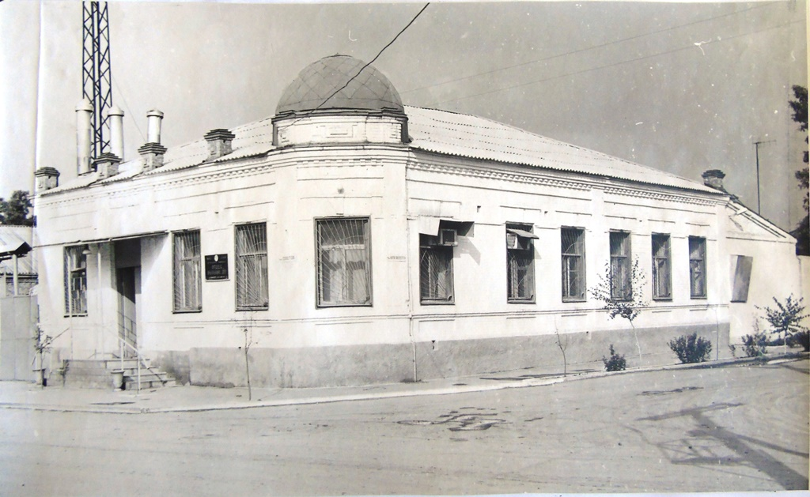
Photo 62. 1960's (Archive Department of the administration of the Shcherbinovsky district municipality)

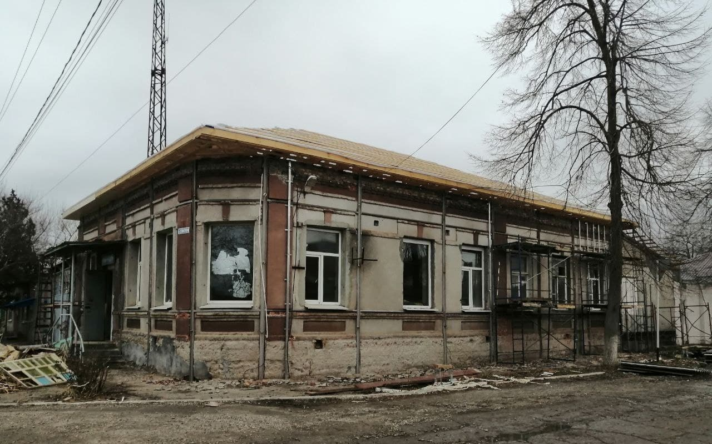
Photo 63 (author E.V. Smola)

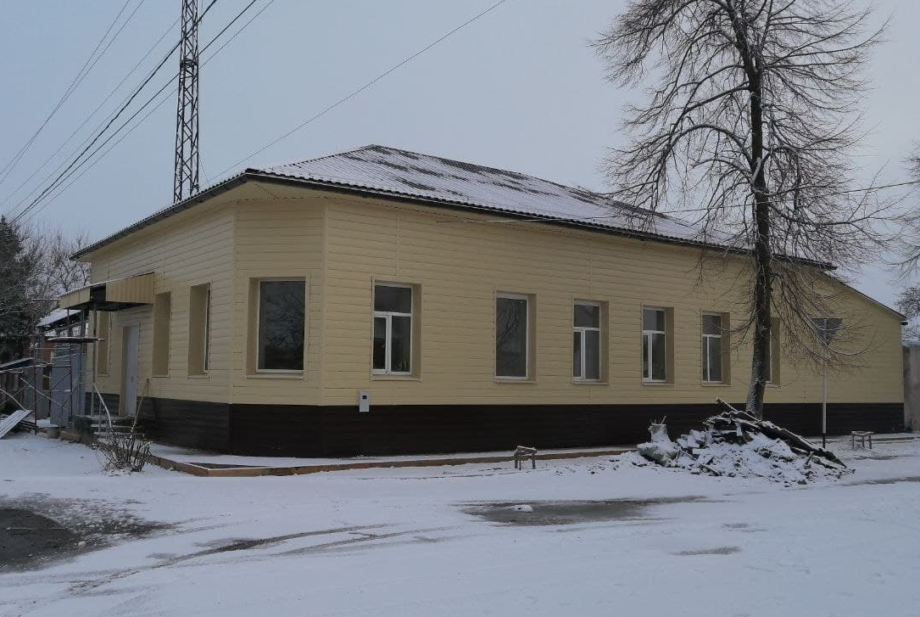
Photo 64 (author E.V. Smola)
Steam Mill
Date of construction: late 19th – early 20th century. Photos 65-69
Location: 127 Pervomaiskaya Street.
Historical information: The first owner is a merchant Krikun (presumably one of the brothers whose households are located in the center of the village – 6. The household of the Cossack Krikun, 8. The household of the Cossack Krikun (brother)).
In the second half of the XX century - stanichnaya mill.
The mill operated until the 2004 fire. [6]
After reconstruction in 2010 – 2012, the building was rebuilt as the Staraya Melnitsa shopping complex (the facade of the building is partially preserved).
There are currently shops here.
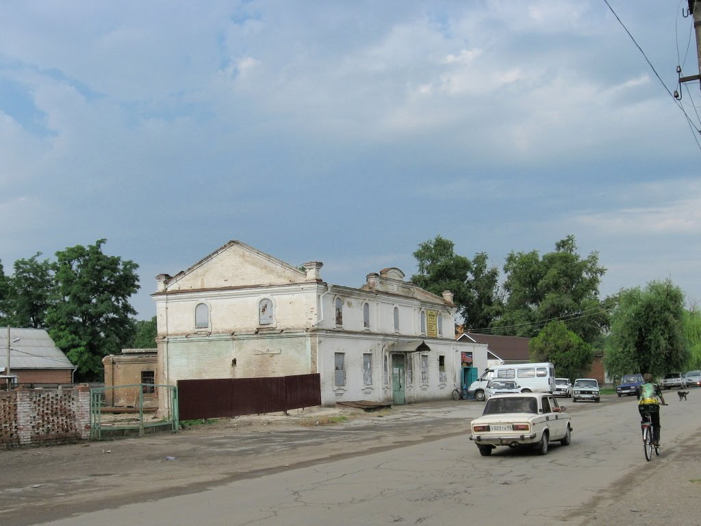
Photo 65. The beginning of the XXI century.
(Archive Department of the administration of the Shcherbinovsky district municipality)

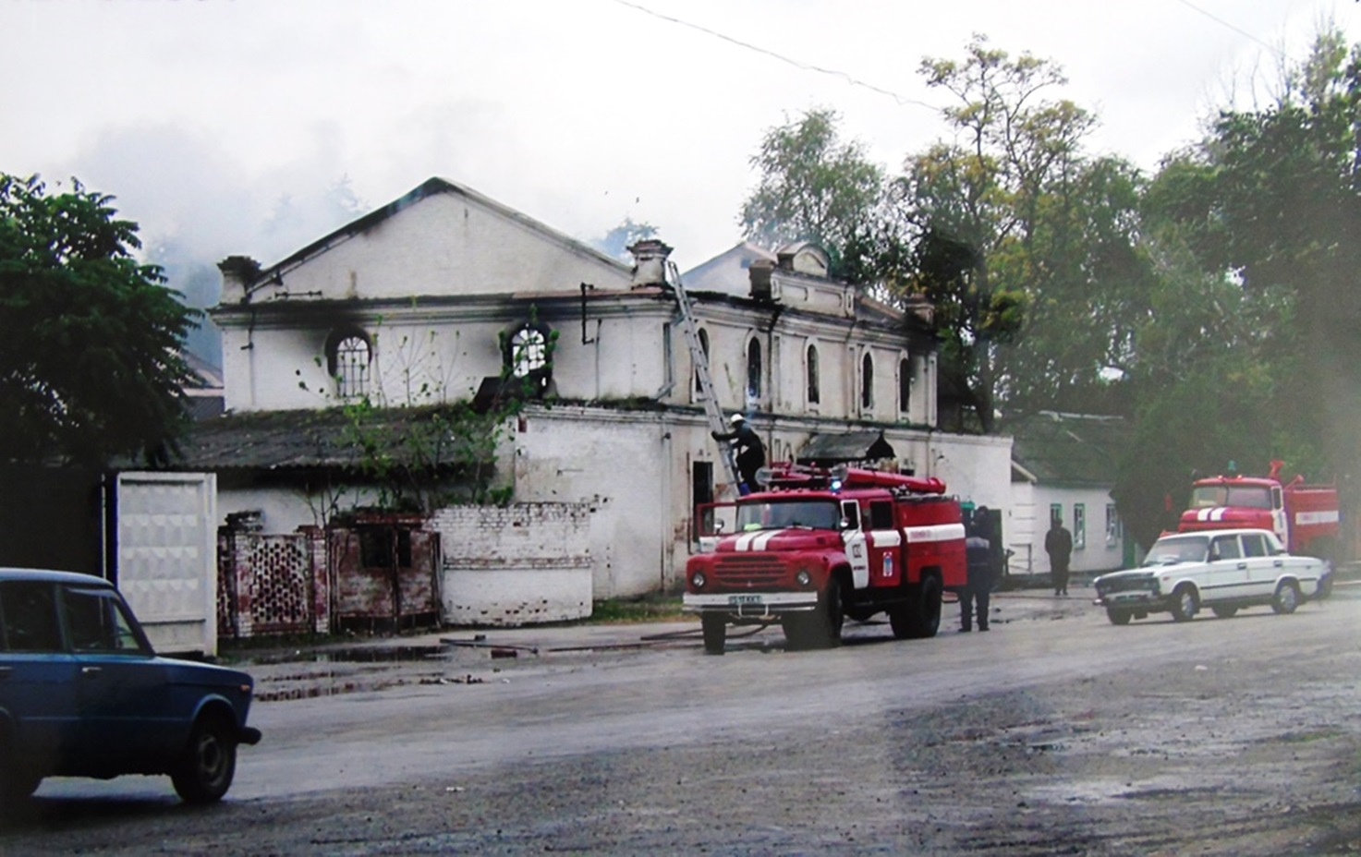
Photo 66. The beginning of the XXI century.
(Archive Department of the administration of the Shcherbinovsky district municipality)

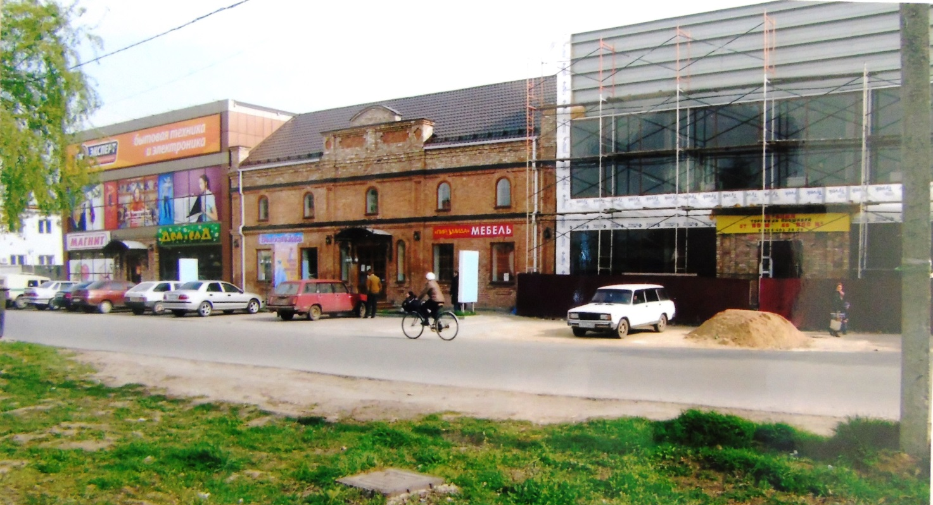
Photo 67. 2012 (Archive Department of the administrationof the Shcherbinovsky district municipality)

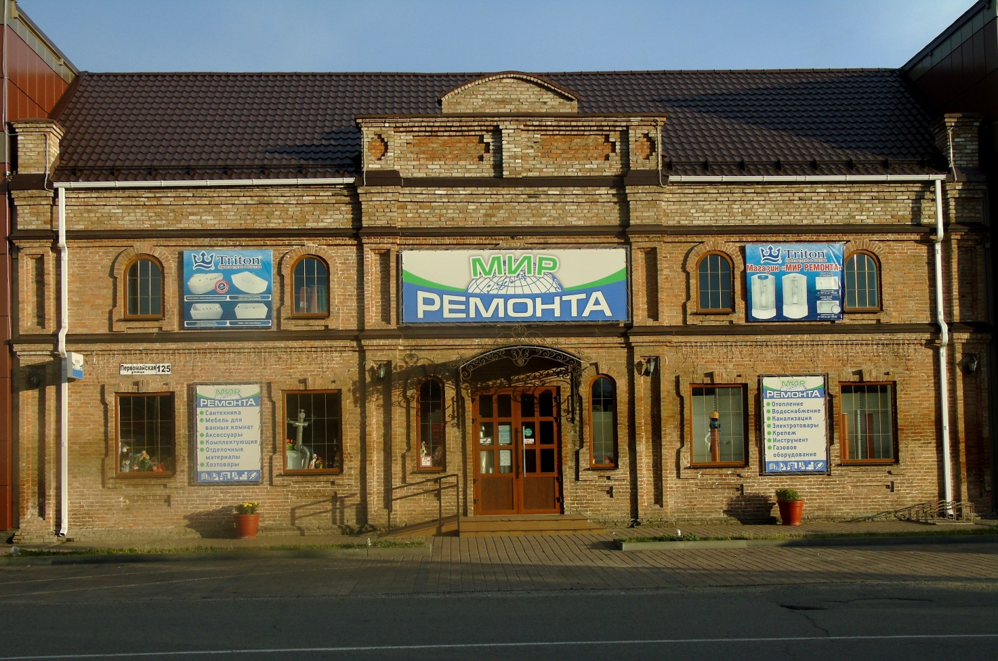
Photo 68 (author E.V. Smola)

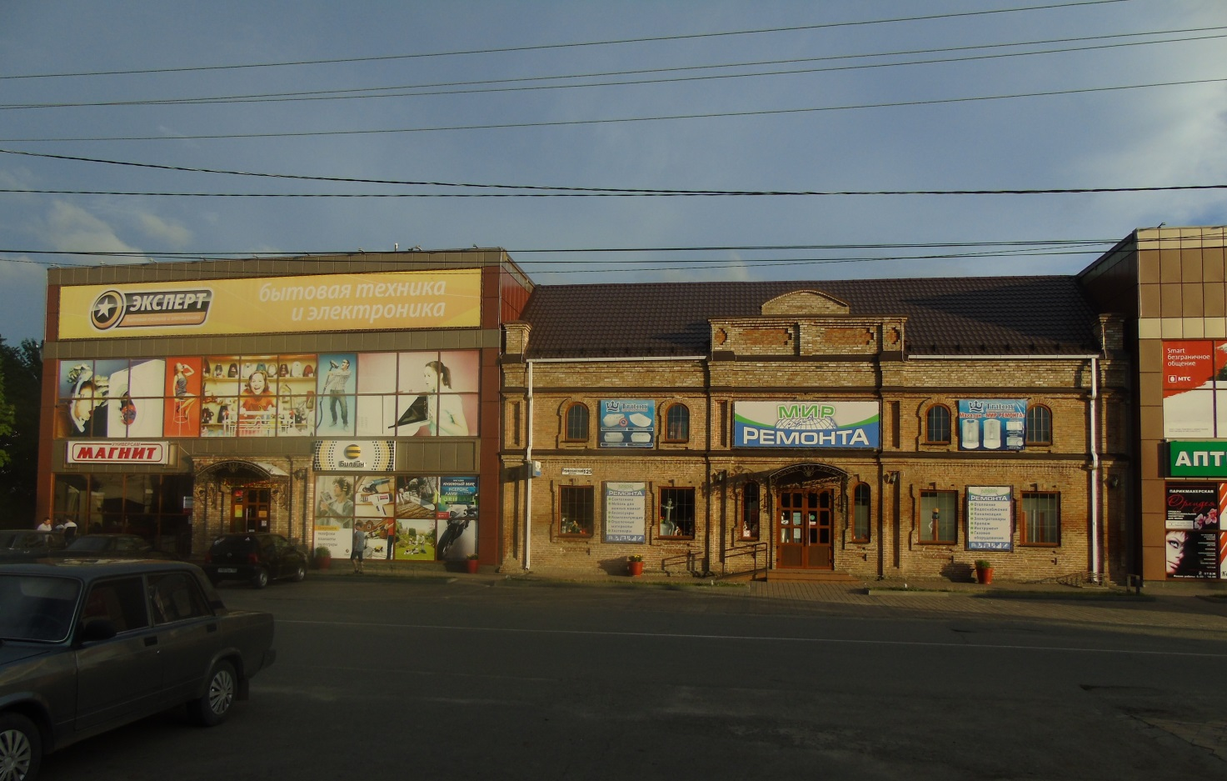
Photo 69 (author E.V. Smola)
Steam oil mill
Date of construction: late 19th – early 20th century. Photos 70, 71
Location: Mira Street, 20.
Historical background: The first owner is the merchant Nikolayev.
During the Great Patriotic War, the building was badly damaged by a severe fire, but later it was reconstructed according to Baronov's design (perhaps there is a typo here, since the most prominent architect of that time was Nikolai Varfolomeevich Baranov (b. 1909), who worked, including in the style of electicism, however, there is information about his participation in the restoration of this object could not be found).
In the 80s - 90s of the last century, there was a stanitsa oil mill. It operated until 2013.
The building is currently abandoned (privately owned).
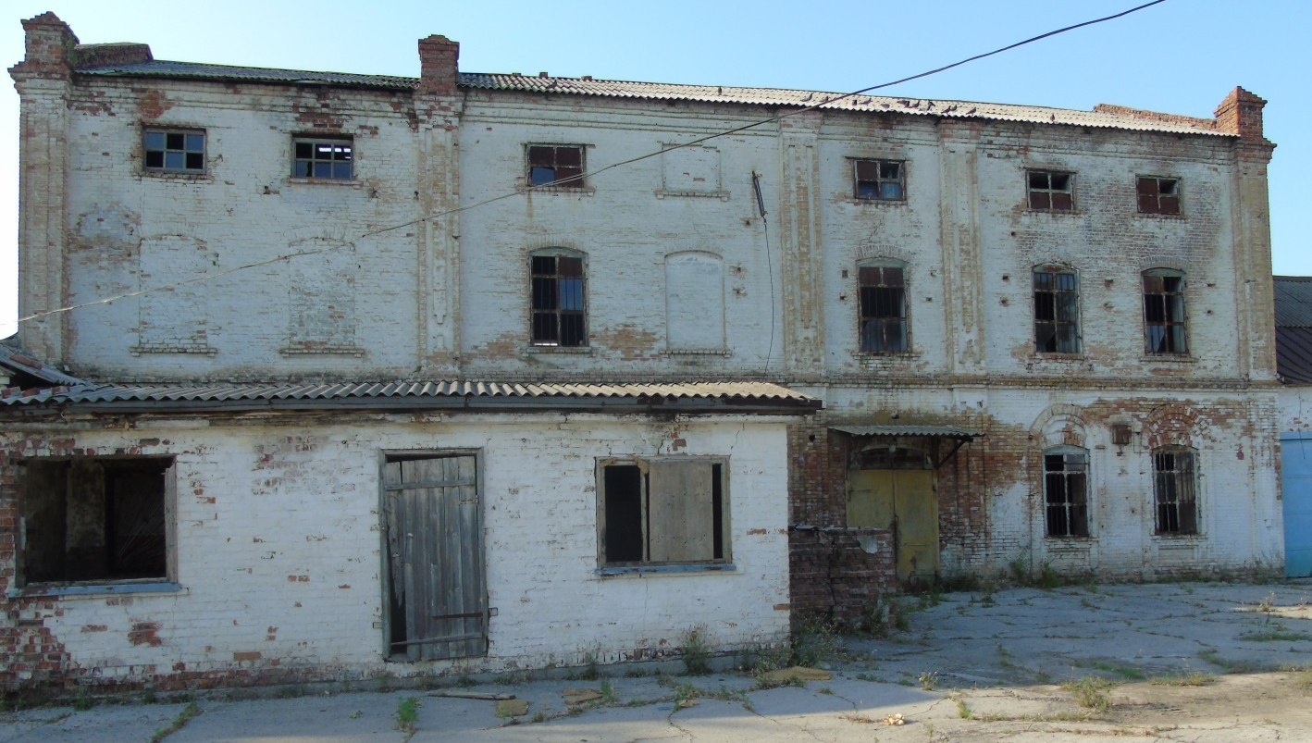
Photo 70 (author E.V. Smola)
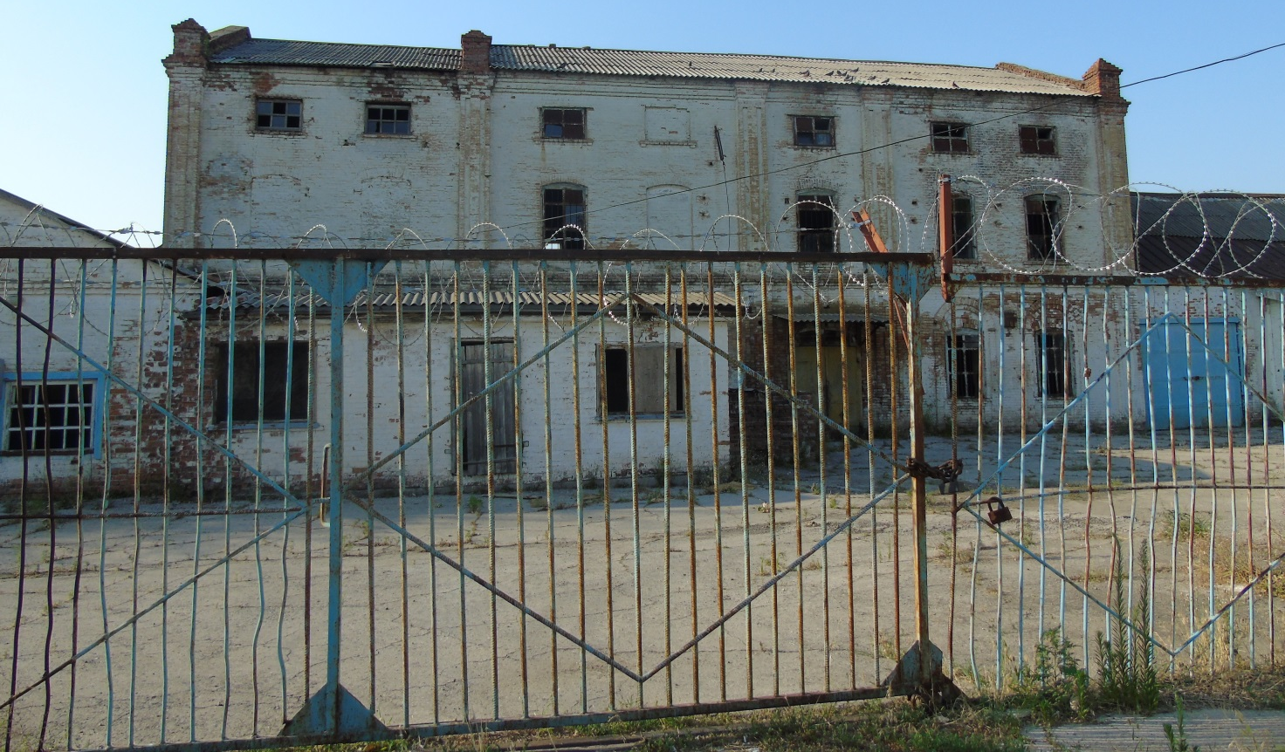
Photo 71 (author E.V. Smola)
Pharmacy of Valery Nikolaevich Motylevich

Date of construction: 1902
Location: 105 Pervomayskaya Street. Photo 72, 73
Historical background: Local residents remember it as "Motylevich’s Pharmacy" (this inscription was once on the building’s façade).
In materials from the website "KUBAN GENEALOGY", a source was found stating that the pharmacy was built by Collegiate Registrar Valery Nikolaevich Motylevich:
"Russian Medical Register Office of the Chief Medical Inspector Ministry of Internal Affairs for the year 1914
List of physicians, veterinarians, dentists, pharmacists, and pharmacies as of May 1, 1914
Pharmacy provisor Motylevich Valer. Nik. – Graduation year: 1910. Staroshcherbinovskaya, Yeisk District, Kuban Region." [183]
In the year the pharmacy was built, a scandalous incident occurred involving Motylevich, mentioned in the following order:
"Order of January 25, 1902, regarding the Kuban Cossack Army, which I am quoting verbatim concerning Staroshcherbinovskaya:
'Cornet of the 11th Kuban Plastun Battalion Orlov, overseeing the administrative district of the Yeisk Division, on October 16 of last year, in response to a verbal complaint from the owner of a private pharmacy in Staroshcherbinovskaya, Collegiate Registrar Motylevich, regarding verbal insults directed at him by non-combatant of the first rank Nikolai Lavrovsky, summoned Lavrovsky to the stanitsa administration and, while investigating Motylevich’s complaint by questioning Lavrovsky, struck him in the face.
For this misconduct committed by Cornet Orlov, I am limiting the punishment this time to his arrest at the Ekaterinodar guardhouse for three days. I order the Ataman of the Yeisk Division to execute this order immediately.
Acting Ataman, Lieutenant General MALAMA'" [8]
From 1965 to 1976, the building housed the Pioneer House and a library.
At the end of the 20th century, renovation work led to the destruction of the original façade inscription, as well as some decorative elements, resulting in the loss of the building’s unique architectural identity.
Today, the building houses the Civil Registry Office (ZAGS).
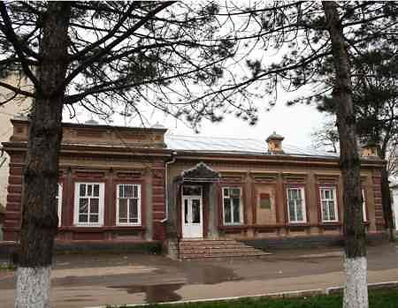
From 72. The beginning of the XXI century. (Archive Department of the administration of the Shcherbinovsky district municipality)

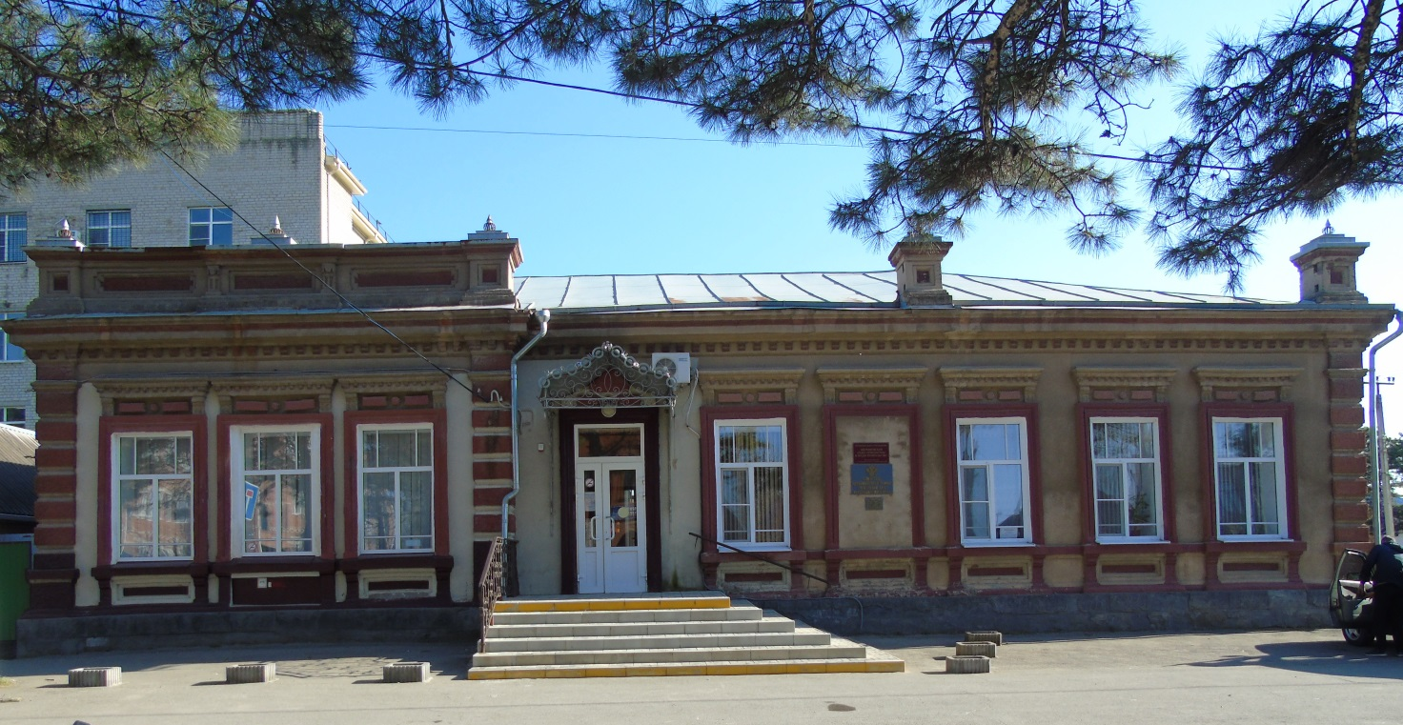
Photo 73 (author E.V. Smola)

DESIGNATIONS AND ABBREVIATIONS

GAKK – State Archive of the Krasnodar Krai (Gosudarstvenny Arkhiv Krasnodarskogo Kraya)
GASK – State Archive of the Stavropol Krai (Gosudarstvenny Arkhiv Stavropolskogo Kraya)
D. – Case / File (Delo)
DOSAAF – Voluntary Society for Assistance to the Army, Aviation, and Navy (Dobrovolnoe Obshchestvo Sodeystviya Armii, Aviatsii i Flotu)
ZhKH – Housing and Communal Services (Zhilishchno-Kommunalnoe Khozyaystvo)
ZAGS Office – Civil Registry Office (Otdel Zapisi Aktov Grazhdanskogo Sostoyaniya)
MBOU SOSh – Municipal Budgetary General Education Institution – Secondary School (Munitsipalnoe Byudzhetnoe Obshcheobrazovatelnoe Uchrezhdenie Srednyaya Obshcheobrazovatelnaya Shkola)
MVD – Ministry of Internal Affairs (Ministerstvo Vnutrennikh Del)
Op. – Inventory (Opis’)
RSFSR – Russian Soviet Federative Socialist Republic (Rossiyskaya Sovetskaya Federativnaya Sotsialisticheskaya Respublika)
RF – Russian Federation (Rossiyskaya Federatsiya)
See (sm.) – refer to (smotret’)
SPK – Agricultural Production Cooperative (Sel’skokhozyaystvenny Proizvodstvenny Kooperativ)
USSR (SSSR) – Union of Soviet Socialist Republics (Soyuz Sovetskikh Sotsialisticheskikh Respublik)
St. – Stanitsa (Stanitsa)
F. – Fund (Fond)
FZ – Federal Law (Federalny Zakon)


BIBLIOGRAPHICAL LIST

1. Archival Documents
1. "Collection of Documents on the History of Shcherbinovsky District" (R-107, inventory 1, file No. 12) – "Documents on Buildings and Structures – Cultural Heritage Sites of Shcherbinovsky District" and the Archival Department Staff’s Own Collecting Activities.

2. Books
2. "The Life of the Righteous Priest Stefan Yankov and Miracles at His Grave in the Stanitsa Staroshcherbinovskaya" / Compiled by Ilya, Georgy, L. D. Pavlogradskaya. - St. Petersburg: Society for the Memory of Abbess Taisia, 2010. - 105 pages; [3] leaves: photos.

3. Articles:
3. Galchenko O. V., Member of the Shcherbinovsky District Branch of the ROIA. The History of the Staroshcherbinovskoye Alekseevskoye One-Class Men's School in the Pre-Revolutionary Period (On the 115th Anniversary of the Founding of Secondary School No. 2 in Stanitsa Staroshcherbinovskaya).
4. Roman Salva. Newspaper "Yeiskie Izvestia," November 3, 1909. Archive.
5. The Mystery of Maltsev. – Yu. Skovoroda, Member of the Shcherbinovsky Branch of the Russian Society of Historians and Archivists // Newspaper "Shcherbinovsky Courier," August 13, 2013 – No. 98.
6. The Mystery of Maltsev (Conclusion). – Yu. Skovoroda, Member of the Shcherbinovsky Branch of the Russian Society of Historians and Archivists // Newspaper "Shcherbinovsky Courier," August 15, 2013 – No. 99.

4. Electronic Resources:
7. "Russian Medical List" – Administration of the Chief Medical Inspector of the Ministry of Internal Affairs for the Year 1914. Lists of Doctors, Veterinarians, Dentists, Pharmacists, and Pharmacies as of May 1, 1914. / Всероссийское генеалогическое древо: https://forum.vgd.ru/3103/87245/0.htm?a=stdforum_view&o=
8. V. Tkachenko-Gildebrandt, V. Shkuro. "The History of One Kurin" / Сайт Кубанского казачьего войска: http://slavakubani.ru/kkv/land-management/law/villages/istoriya-odnogo-kurenya/
9. "Loan and Savings Association" / Википедия: https://ru.wikipedia.org/wiki
10. "Eminent Shcherbinovites" – Biographical and Genealogical Reference Book / http://www.kaz-volnoe.narod.ru/page180.html
11. "Documents on the History of Stanitsa Staroshcherbinovskaya" / Сайт Кубанская генеалогия: http://kubangenealogy.ucoz.ru/index/staroshherbinovskaja_st/0-32

12. Materials of GASK – AlekseiN, Section Moderator, Diary, June 11, 2018, 19:57 / http://forum.vgd.ru/2697/90498/0.htm

