Удалова Ирина Владимировна,
МБОУ СОШ №81 п. Юловский Сальского района,
учитель иностранных языков, заместитель директора по УВР
Урок-соревнование для 6 класса « Merry English»
Teacher: Glad to meet you, dear boys and girls, guests and teachers! Today we are having a competition « Merry English». ( Children divide into 2 teams). Now the teams will introduce themselves. Please, you are welcome!
( участники, представляют название команды, девиз, могут прочитать стих, спеть песню и т.д.)
The 1st round “Read the word according the transcription” (Teams get cards and do it in turns. (1 point for each right answer).
The 2nd round « Sights of London»
- Name as many sights of London as you can. Don’t repeat the sights of another team
( 1 point for each sight)
- Look at the pictures and name the sights of London ( teams do it in turns) ( 1 point for each right answer).

The 3rd round «Read the sentence» ( You have 3 minutes to do the task. The team can get 10 points for the right reading)
Прочитай предложение, вычеркнув лишние буквы. Какие это буквы?
- ou 2) ao 3) au

For the 1st team

Auaaubeautifulauchurchaustandsauinautheaucentreauofautheaucityau.
for the 2nd team
- ou 2) ao 3) au
Aoaaobeautifulaomuseumaostandsaoinaotheaocentreaoofaotheaopark.

The 4th round « Professions» (1 point for each correct word)

Members of the teams in turns should take the cards with words and form the words, meaning a profession.

The 5th round “ Find the words”. Find and make as many words as you can from two parts (words, names, days, months, seasons)
Example: Ju + ly =July Ju + ne = June

The beginning of the words:
Se_______
Fr________
Sa________
Ap_______
The endings:
ndwich iday turday ple ril esh m cretary cond om og iend ptember ven

The 6th round “Complete the text”. Use the articles a\an, the if necessary ( if not, put (-))
( Each team has got different texts and can get 1 point for each correct use of the article)

The 7th round “The comb” You see the table with the word. Make new words beginning with the first letter of this word ( for the word consisting of 5 and more letters a team can get 2 points)

ПОДВЕДЕНИЕ ИТОГОВ.

НАГРАЖДЕНИЕ КОМАНД.

Appendix 1
Транскрипция к словам

Church
Secretary
Businessman
Jumper
Course
Interpreter
Centre
Ancient
Scientist
Banker

Appendix 2 Guess the sights of London

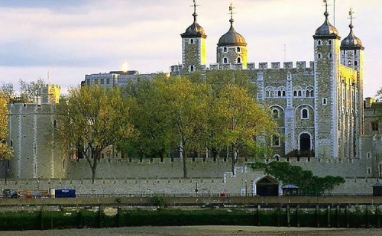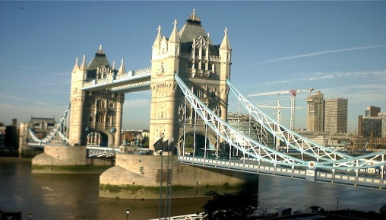

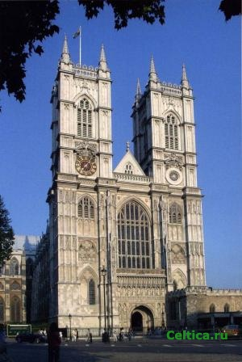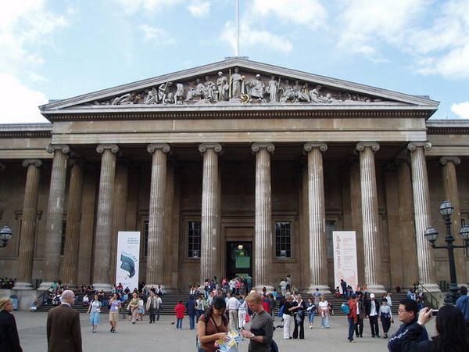

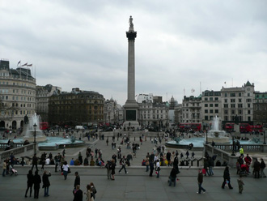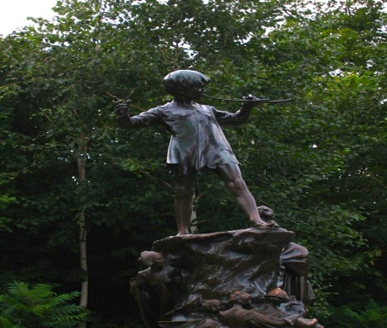

Appendix 3 Read the sentence.

For the 1st team

- ou 2) ao 3) au

Auaaubeautifulauchurchaustandsauinautheaucentreauofautheaucityau.
for the 2nd team
- ou 2) ao 3) au
Aoaaobeautifulaomuseumaostandsaoinaotheaocentreaoofaotheaopark.

Appendix 4. Build the words, meaning a profession
politics
work
sport
swim
bank
science
music
play football
dance ballet
art
jump
fire
cook
manage

Appendix 5. Find and build new words
esh
Se
iday
ndwich
cretary

Fr
tursday
ple
om

ril
m
iend

Sa
og
cond

ptember
ven
Ap

Appendix 6. “Complete the text”.

____Moscow is____capital of___Russia. _____city is ____most beautiful city in____Russian Federation. It is on____Moskva river.
____Kuznetsovs live in____Lenin Street. They have ___son and ___daughter. ___daughter is __artist. Her birthday is on___23rd of _____October.

Appendix 7. “The comb”

s | m | a | r | t

