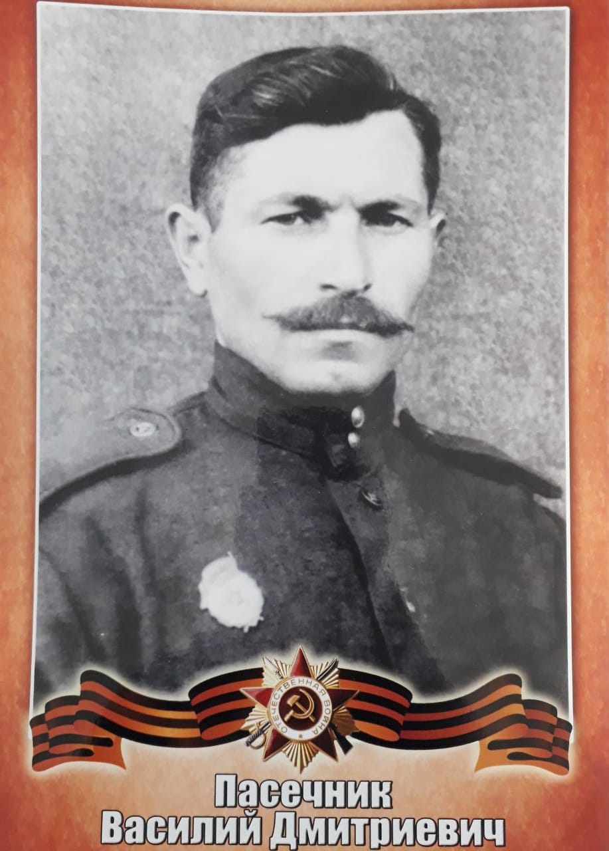

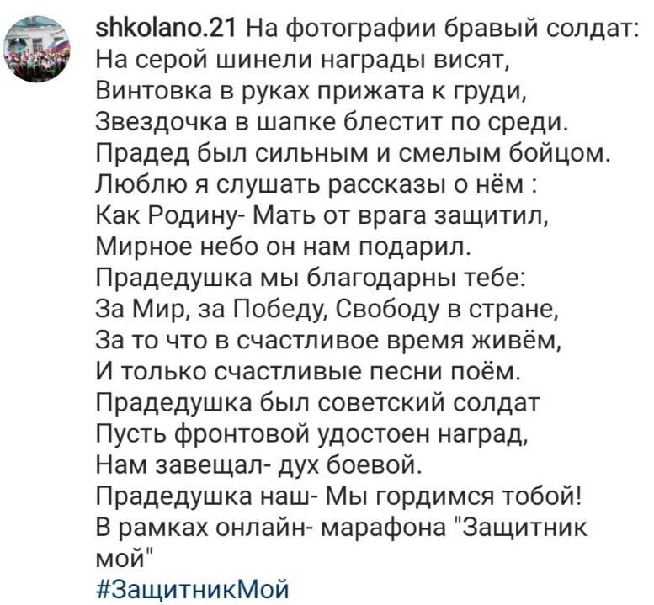

https://www.instagram.com/p/CaHmFBUMO52/?utm_medium=copy_link

